**6CS005 Learning Journal - Semester 1 2019/20**

**Name:** Avipsha Giri

**Student Number:** 1928577

**Table of Contents**

**1. POSIX** 3

**1.1 Password Cracking Using Posix Threads** 3

**1.2 Image Processing using Posix Threads** 9

**1.3 Linear Regression using Posix Thread** 24

**2.1. Password Cracking** 37

**2.2. Image Processing** 40

**2.3 Linear Regression** 44

**3.** **Message Passing Interface** 50

**3.1.** **Password Cracking** 50

**3.2.** **Image Processing** 56

**3.3.** **Linear Regression** 61

# **1. POSIX Threads**

## **1.1 Password Cracking Using Posix Threads**

a. Insert a table of 10 running times and the average run-time.

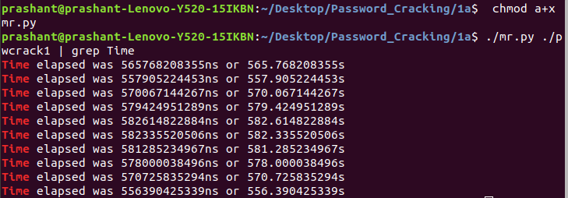

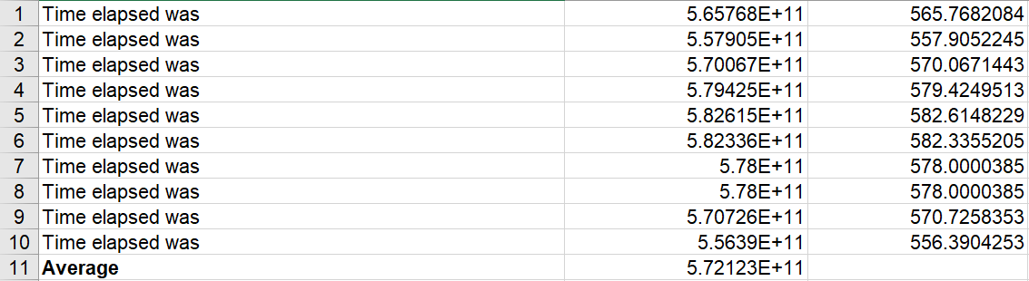

Simple program of cracking 2 initial password was executed for 10 times to calculate average runtime which takes an average of 5minutes.

**Source Code:**

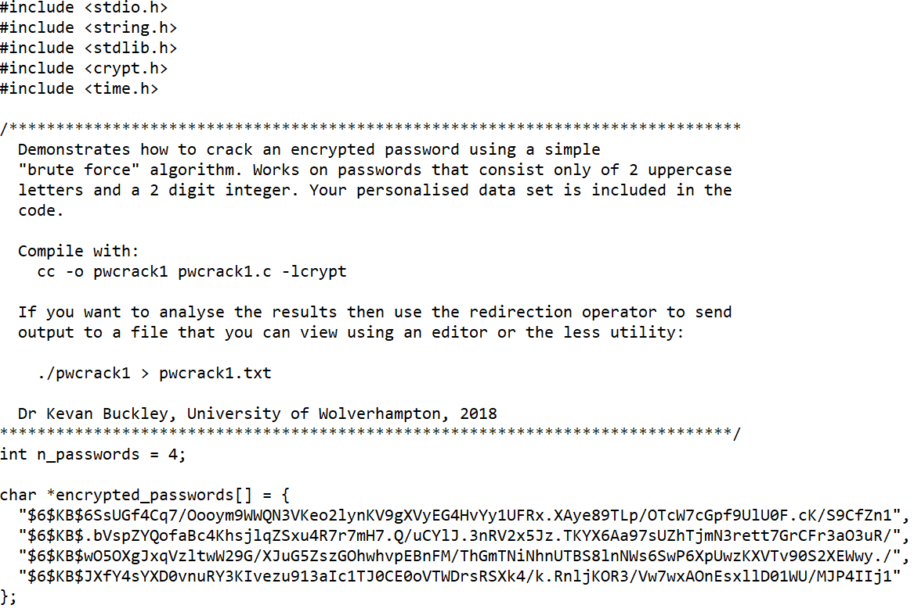

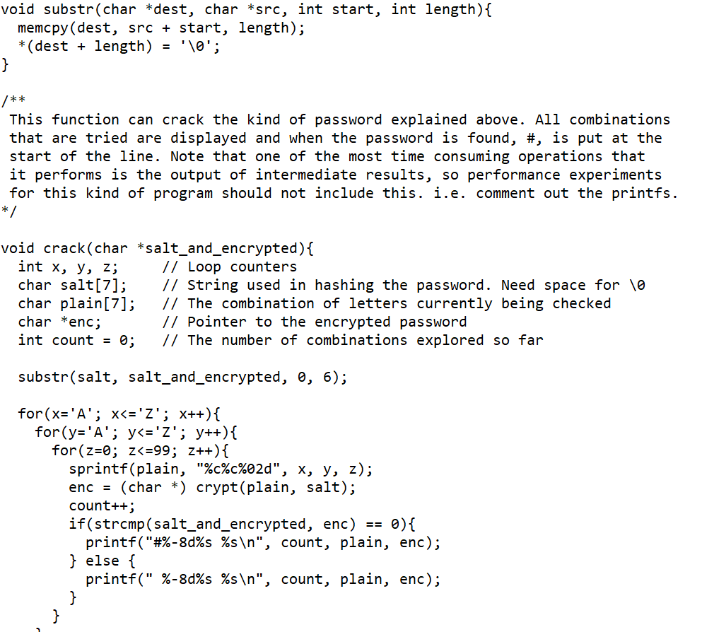

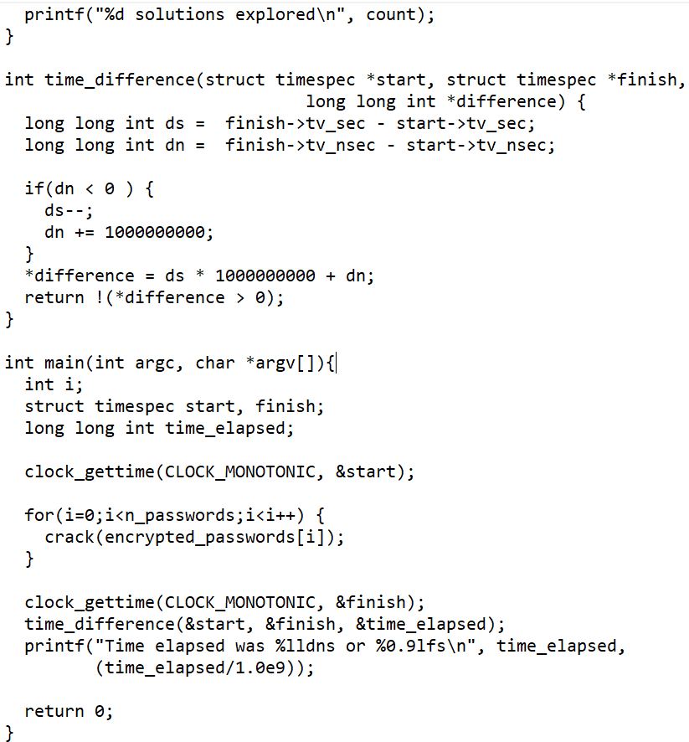

b. We cracked 3 alphabets and 2-digit numbers in this program. The SHA-512 algorithm was used to encrypt the password first. The following figure shows the encryption of 3 initial password:

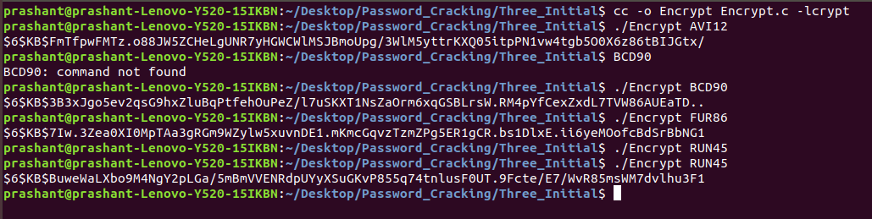

**Source Code for encrypting Password:**

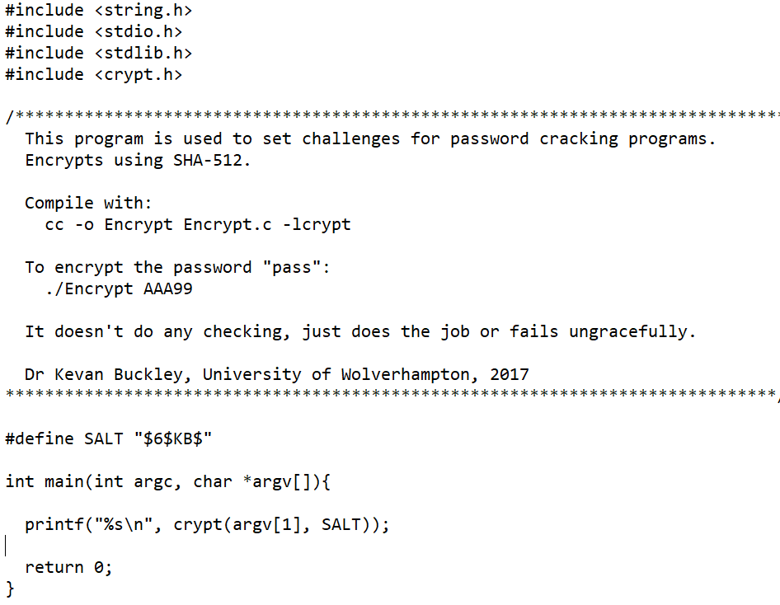

If the number of initials were to be raised to 3, it would take relatively more time than two initials. It is apparent that running two initial programs takes about 9 minutes, but if the initial program is increased, it is evident that the time will increase as the program goes through each and every loop. If the initial were to be raised to 3, it would take 26 more days, which means it will take around 572* 26= 14,872 second time to complete 3 initials.

**Source Code for Three Initial Password Crack:**

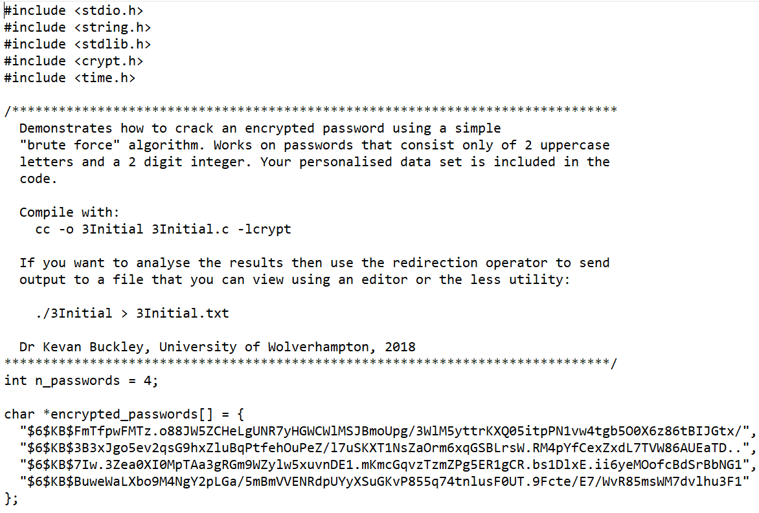

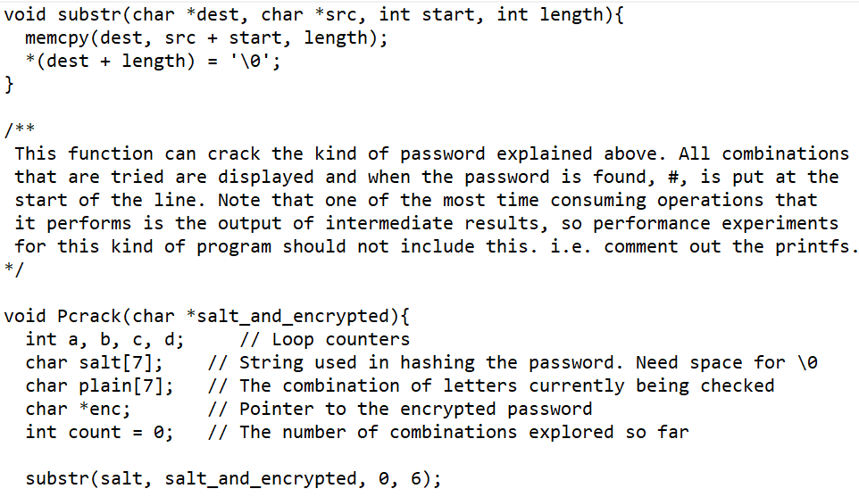

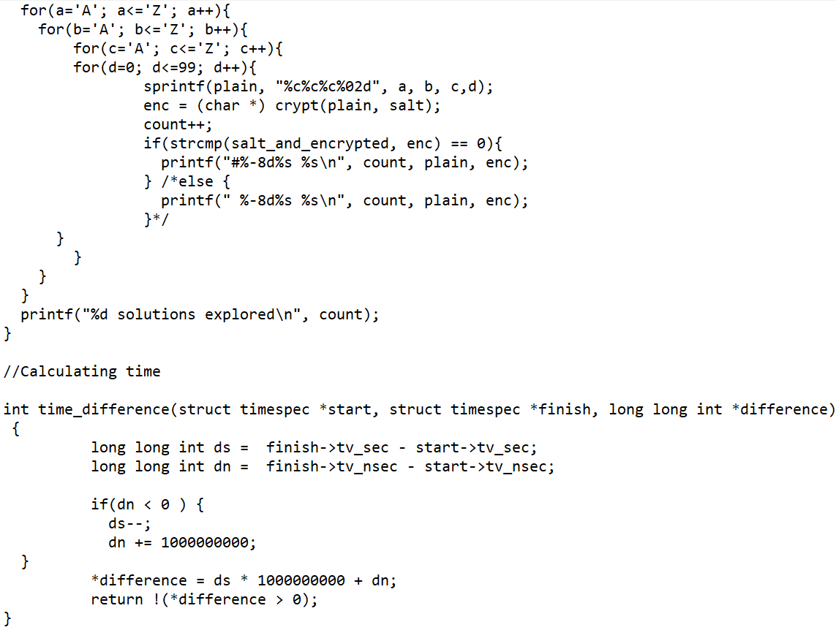

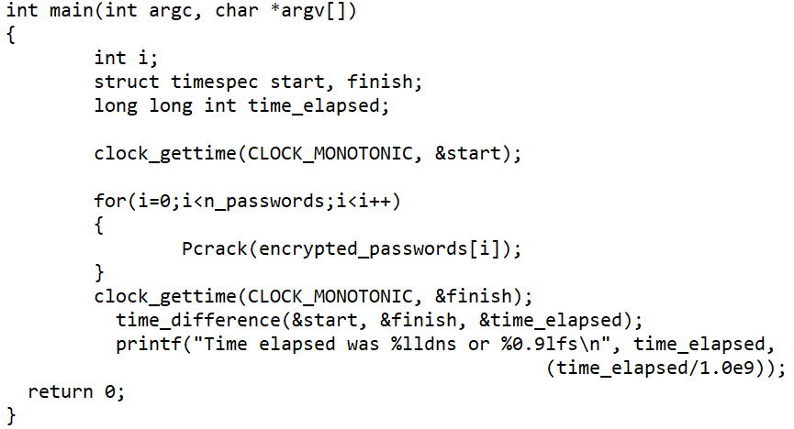

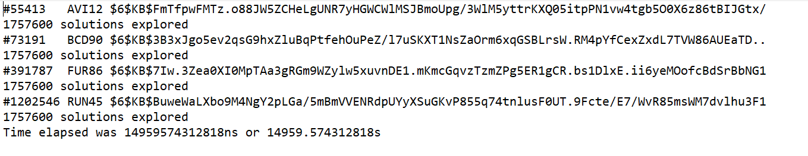

According to the estimation I mentioned that completing 3 initial software would take about 14,872 seconds, but it took about 14959.57 seconds.

The time difference between the actual time and the estimated time is calculated below.

Time Difference =14872 - 14959.57

= -87.57

## **1.2 Image Processing using Posix Threads**

a. Result after running the program:

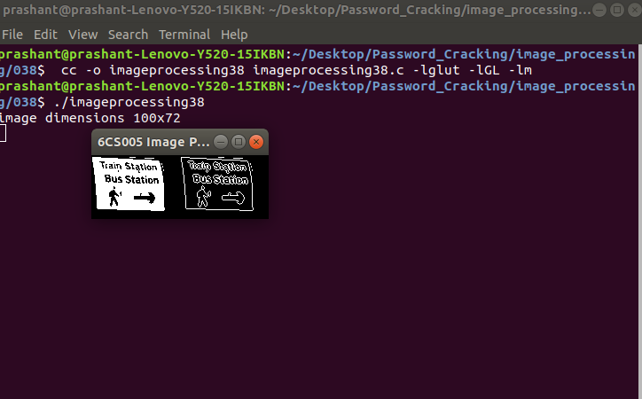

**Source Code of Image Processing using Posix thread:**

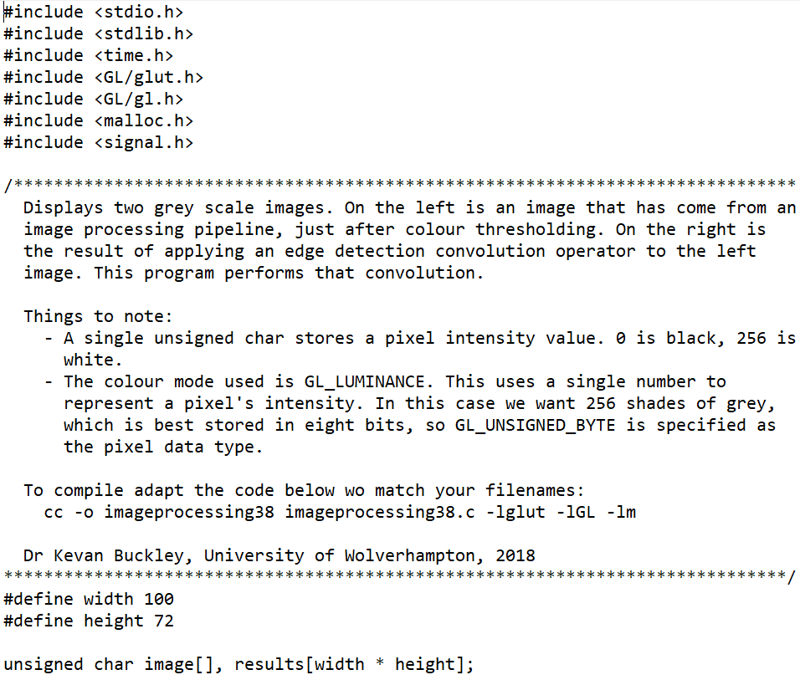

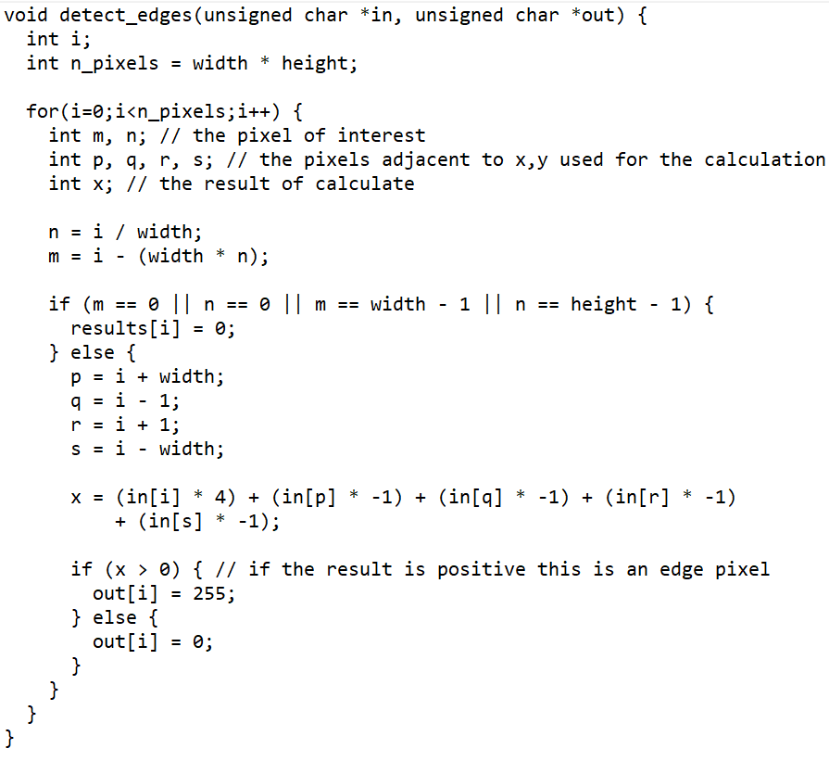

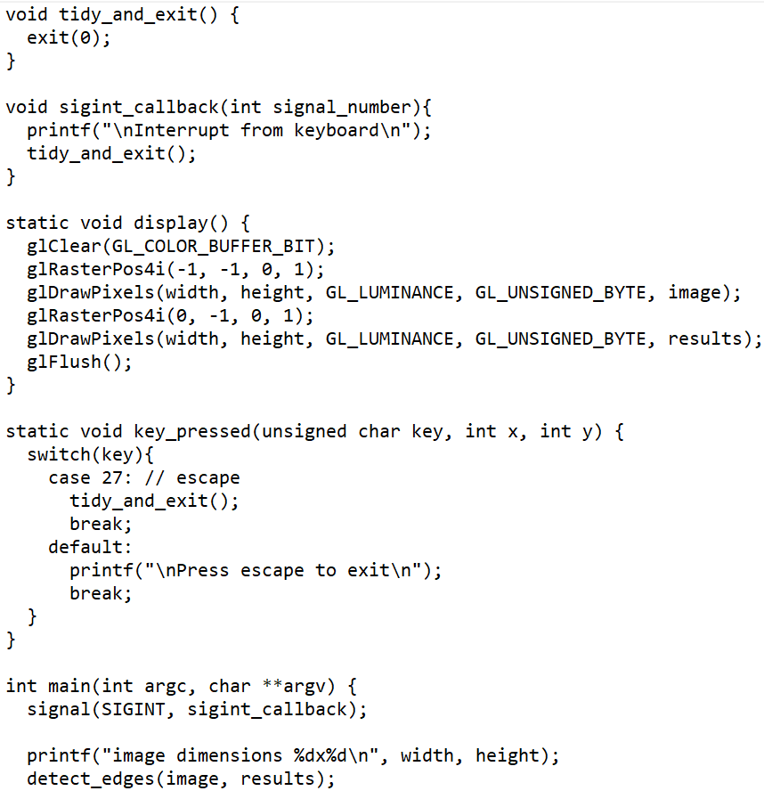

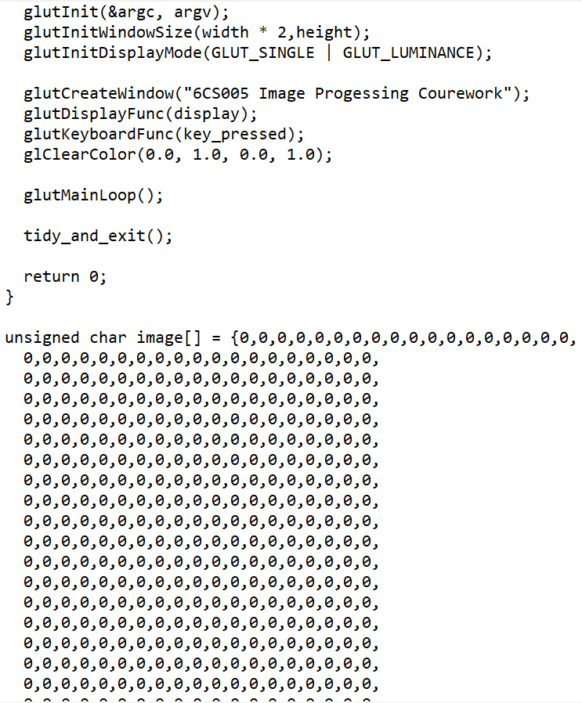

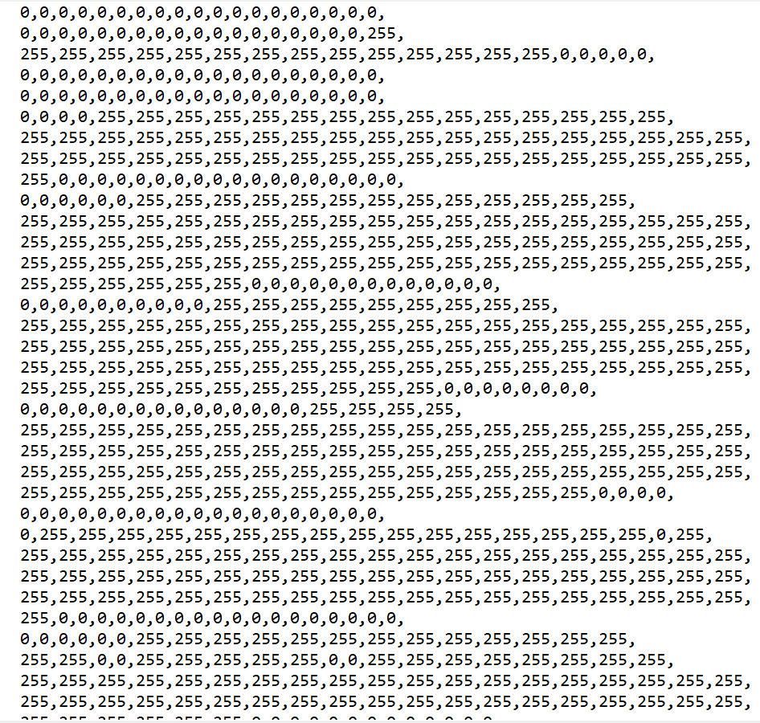

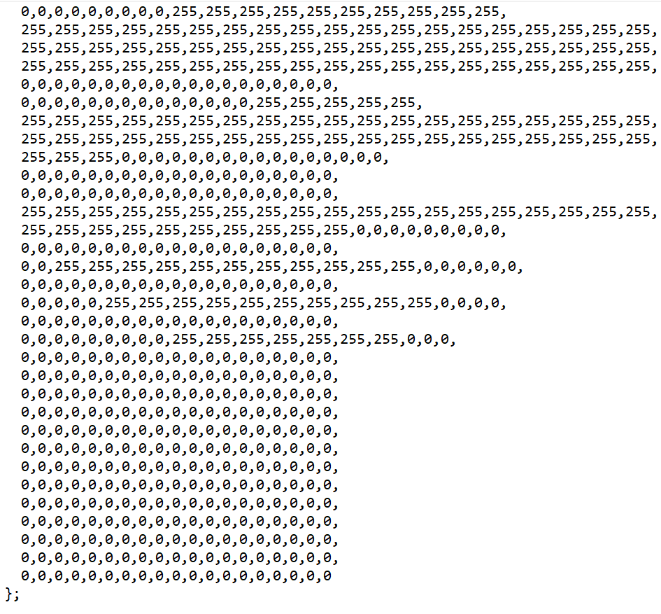

b. Table that has columns containing running times for the original program and the multithread version.

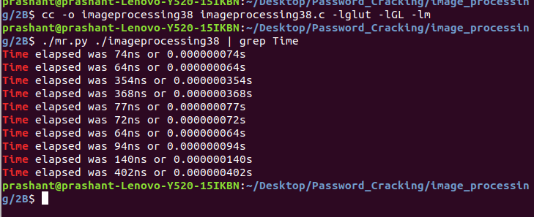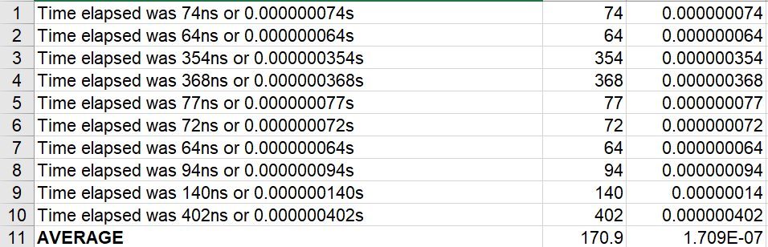

**Source Code:**

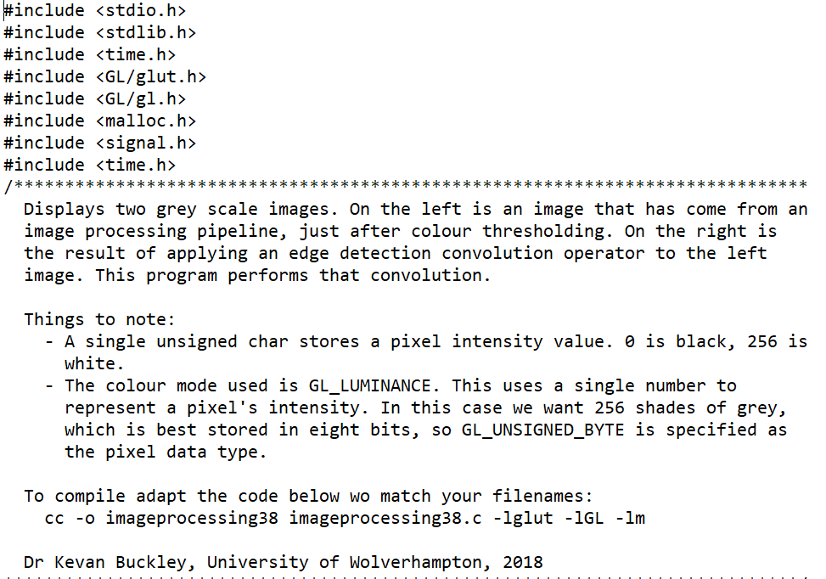

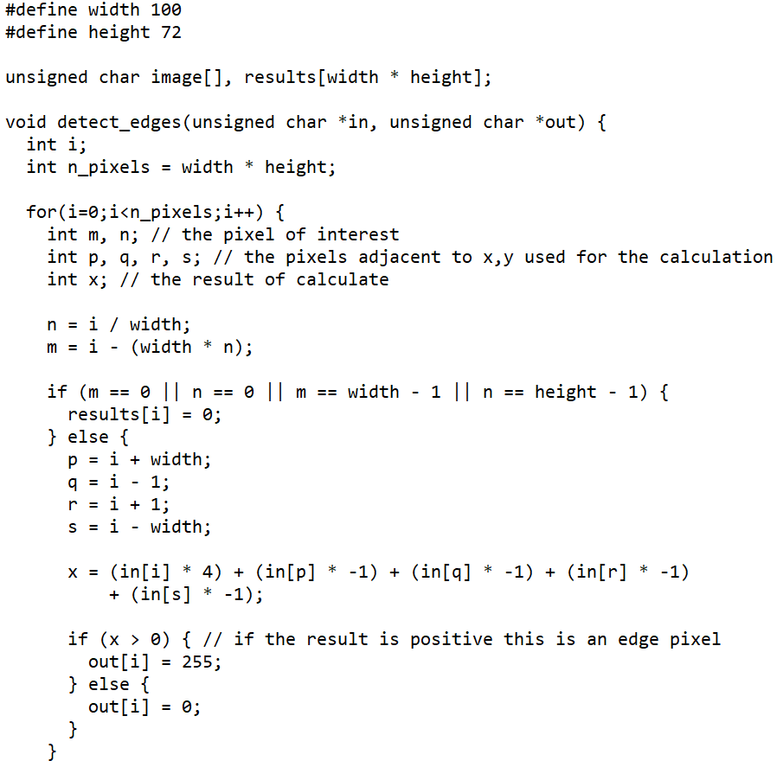

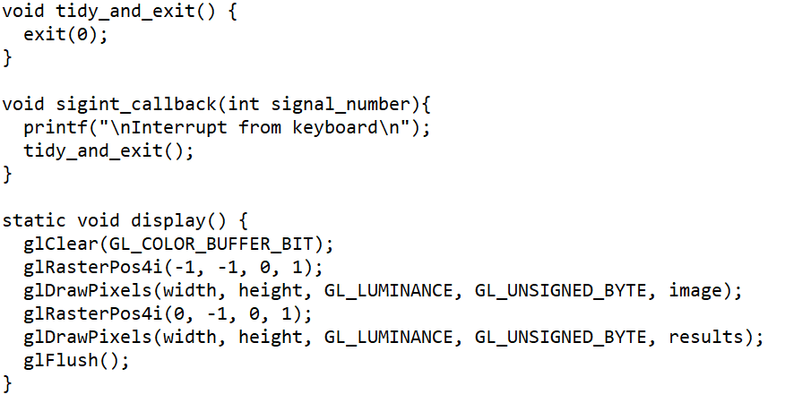

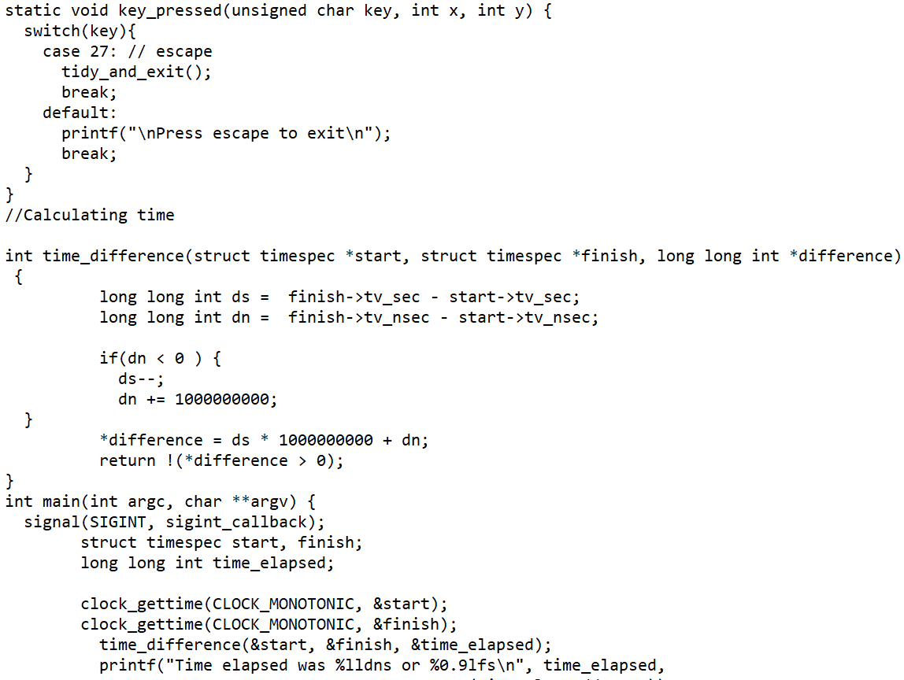

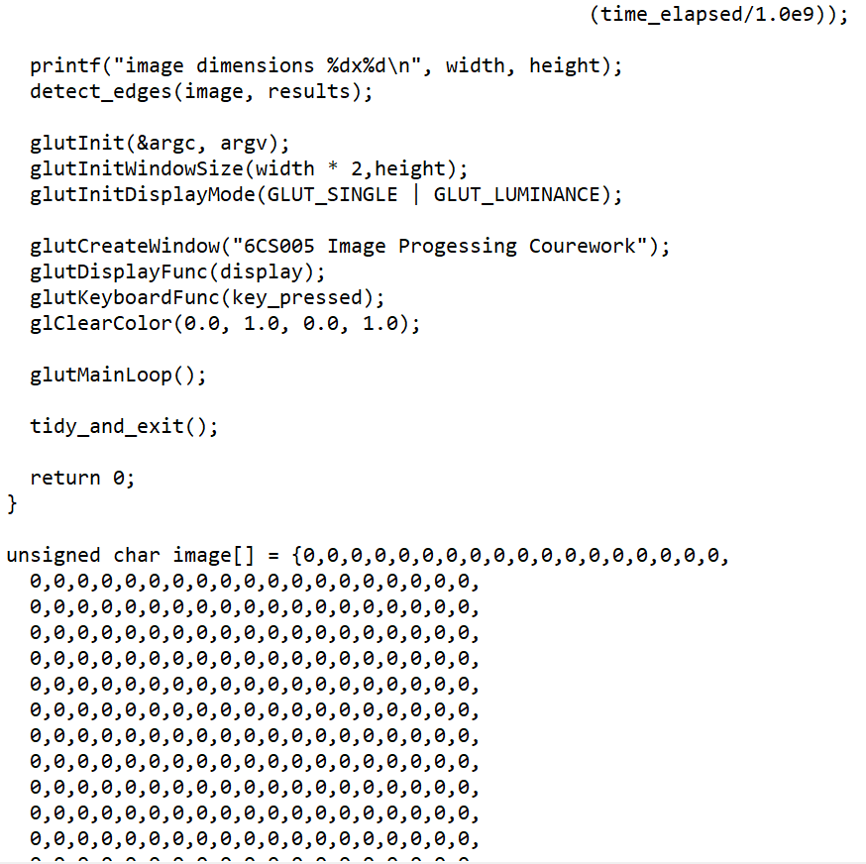

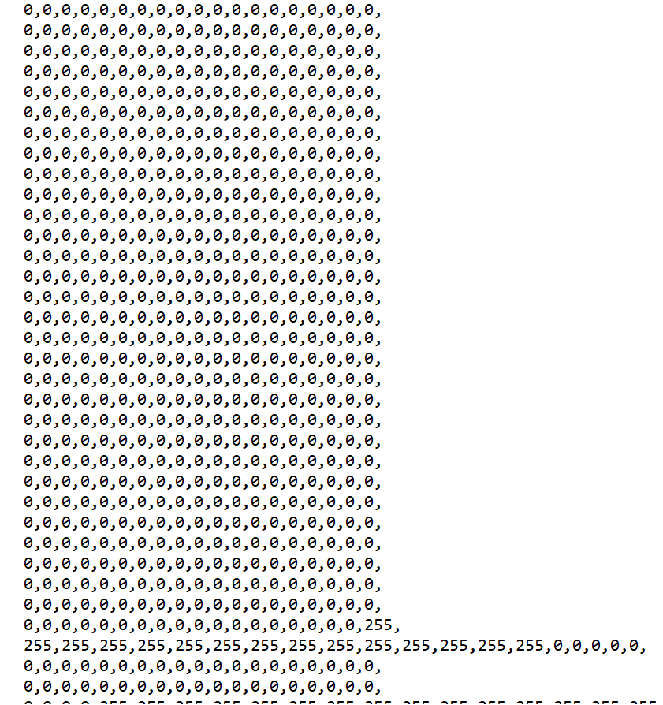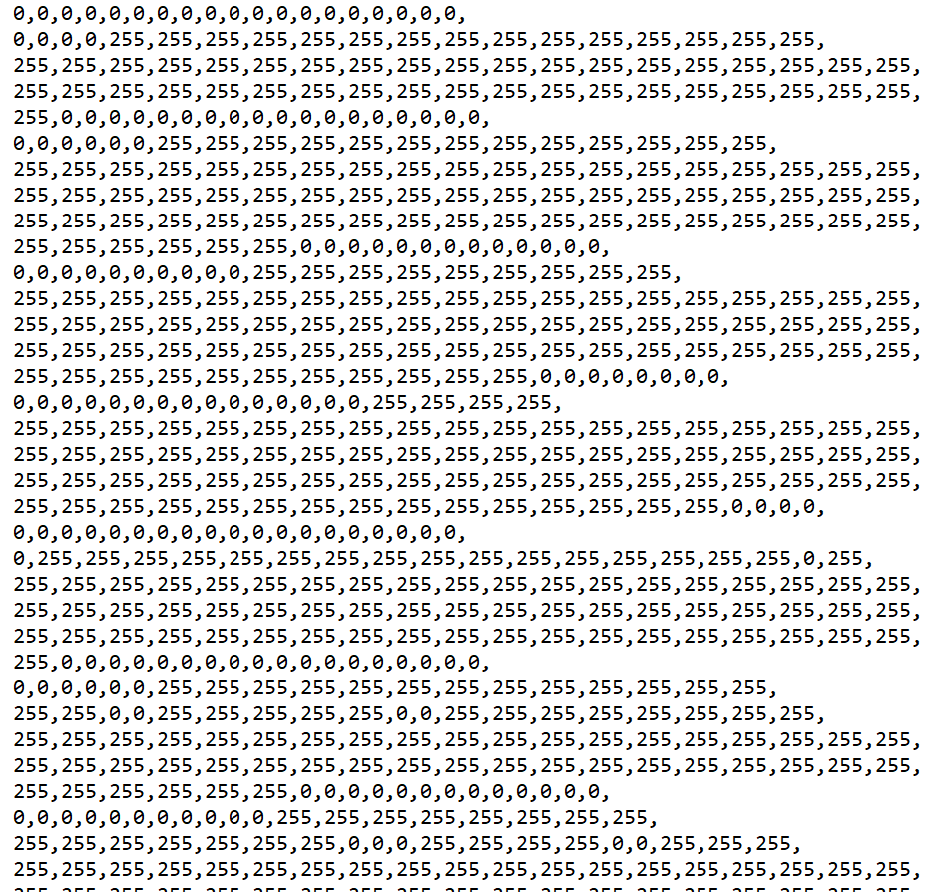

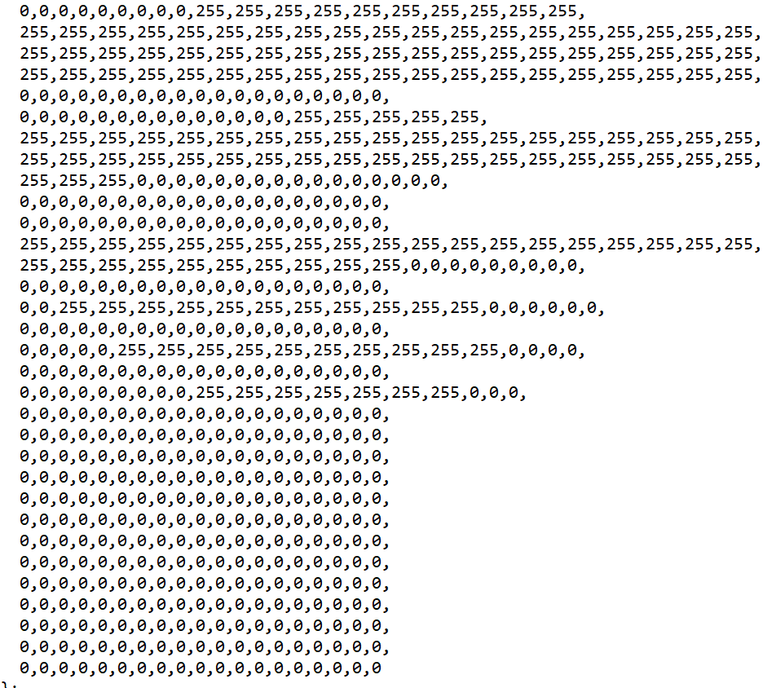

c. Compare the relative running times of the original edge detection program, with the multithread one.

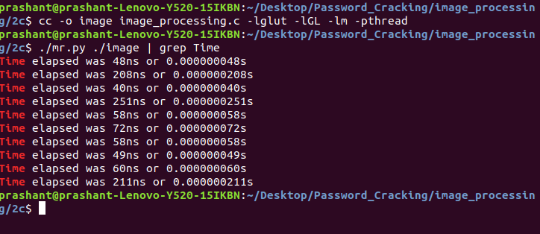

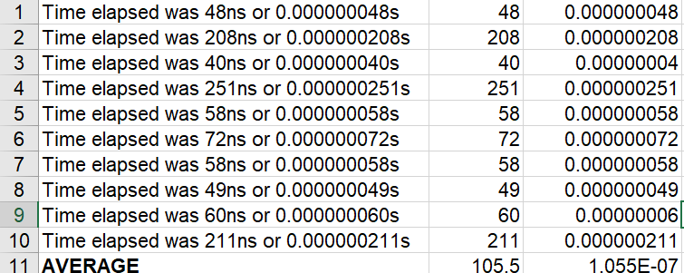

Insert a table that has columns containing running times for the original program and your multithread version. Mean running times should be included at the bottom of the columns.



The table above displays the average runtime of the multithreading image processing program. It is obvious that it takes less time for the software that used multithreading program than a simple program. This is because efficiency and competitiveness are improved by the multithreading system.

**Source Code:**

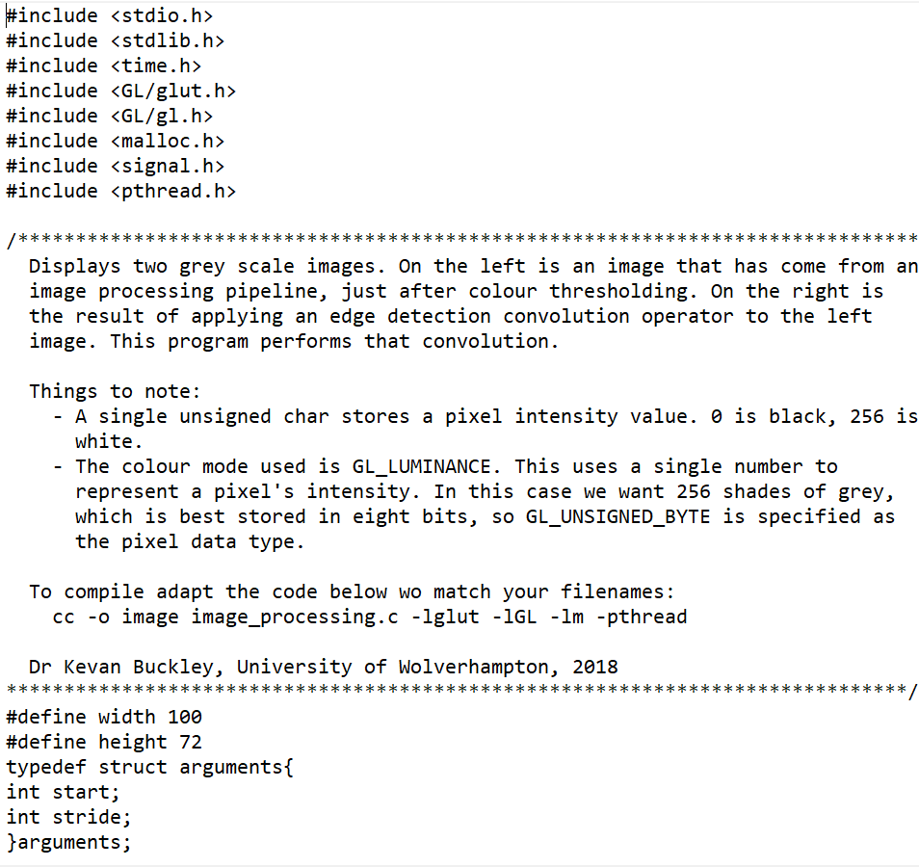

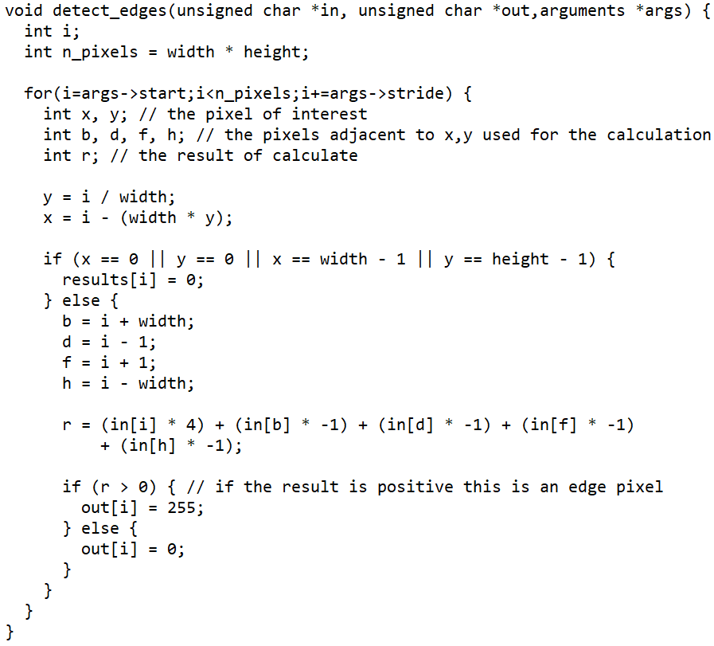

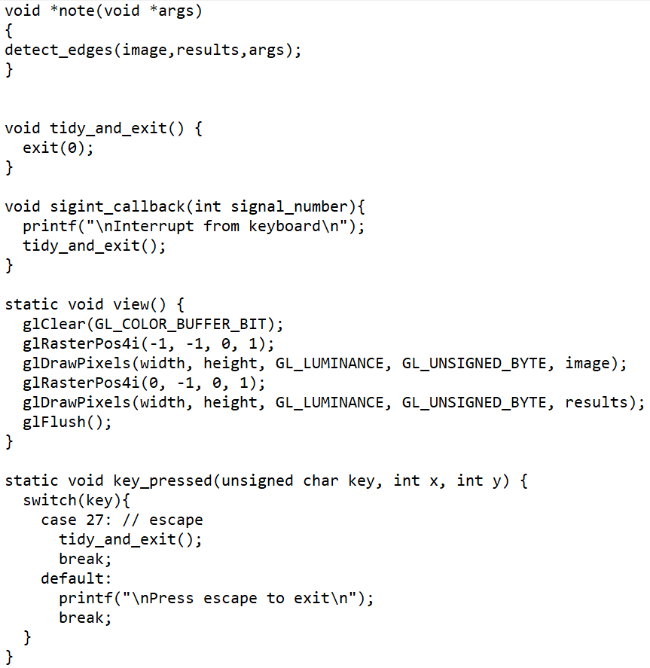

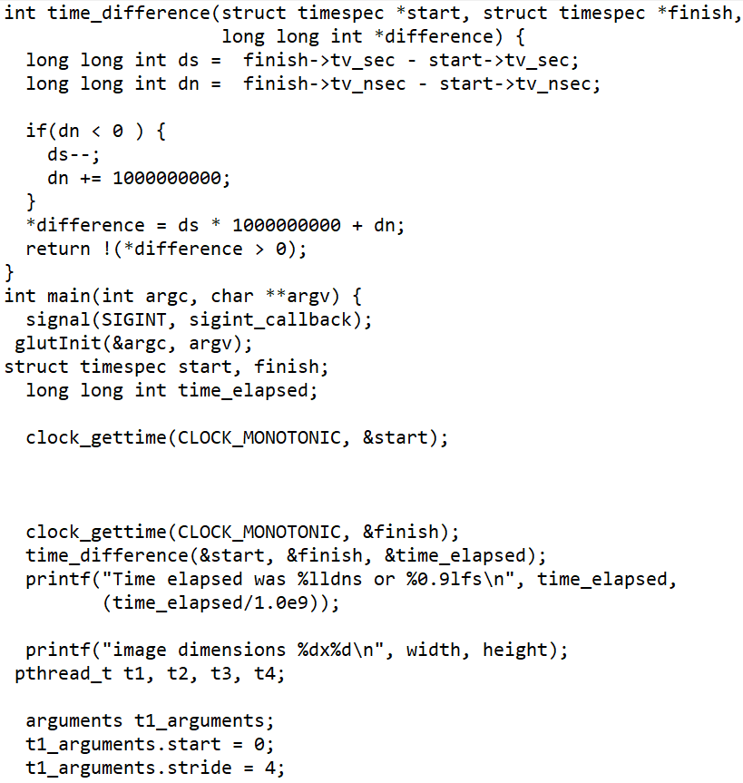

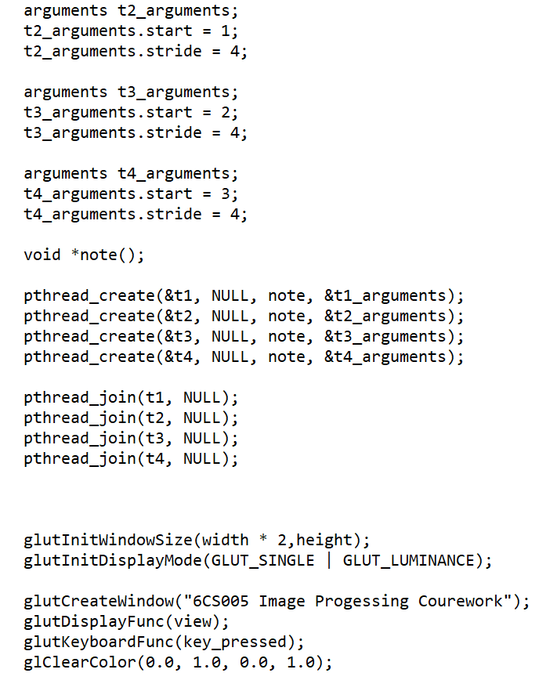

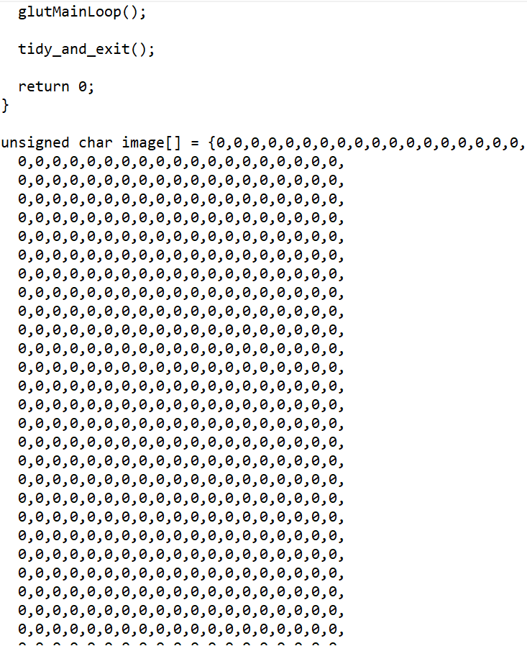

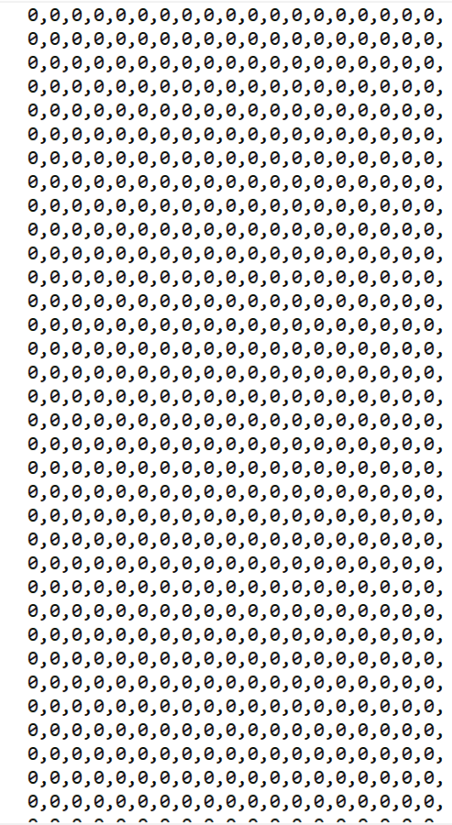

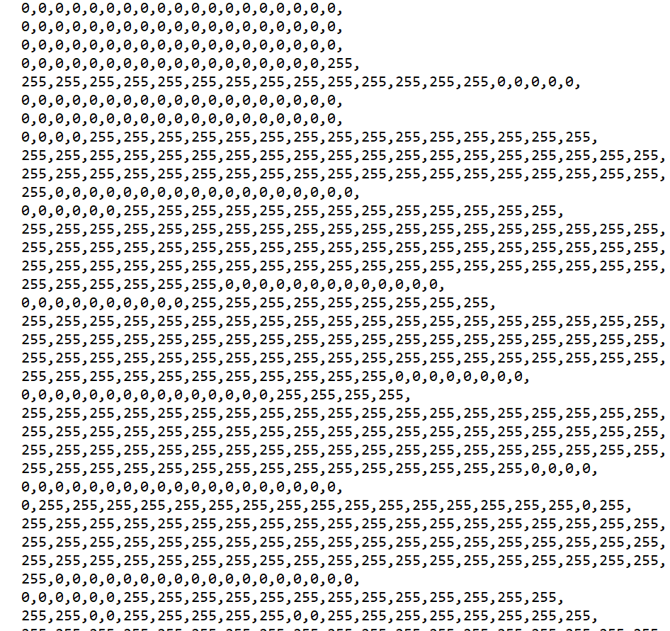

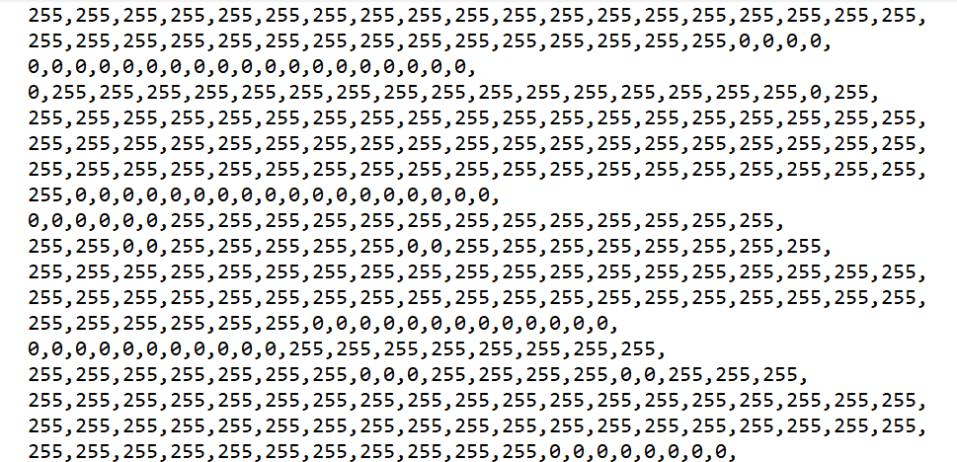

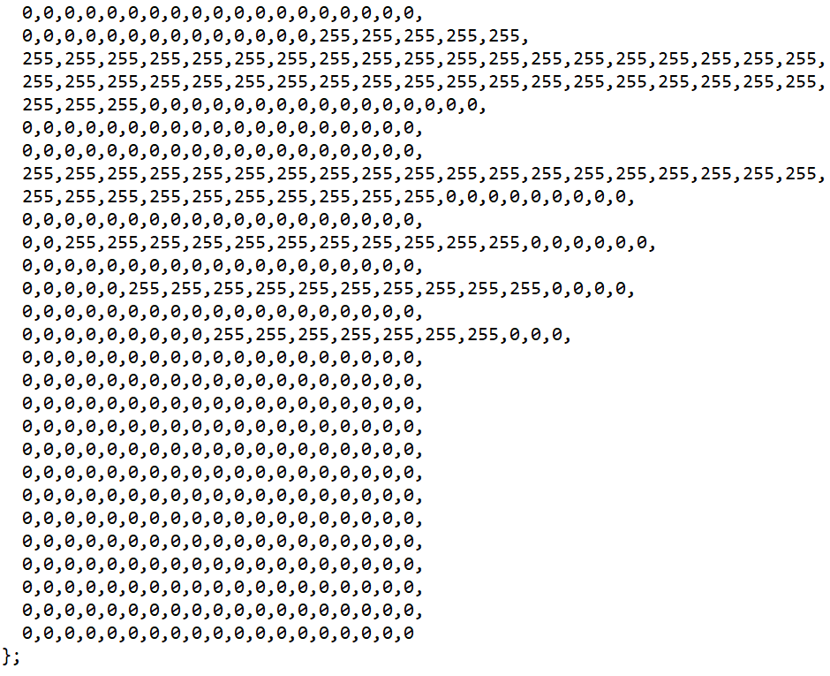

## **1.3 Linear Regression using Posix Thread**

a. Scatter plot of Portfolio

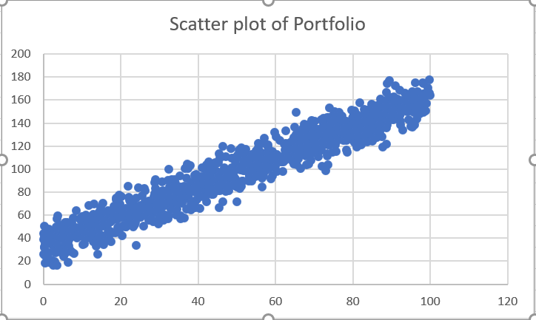

**Source Code:**

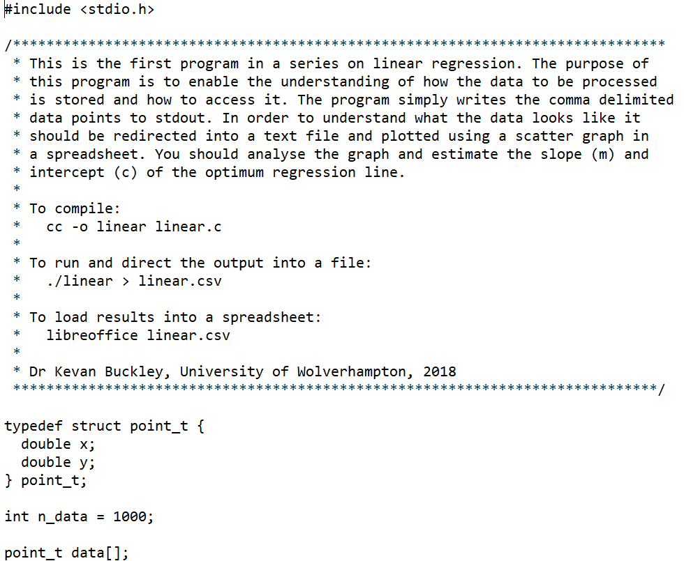

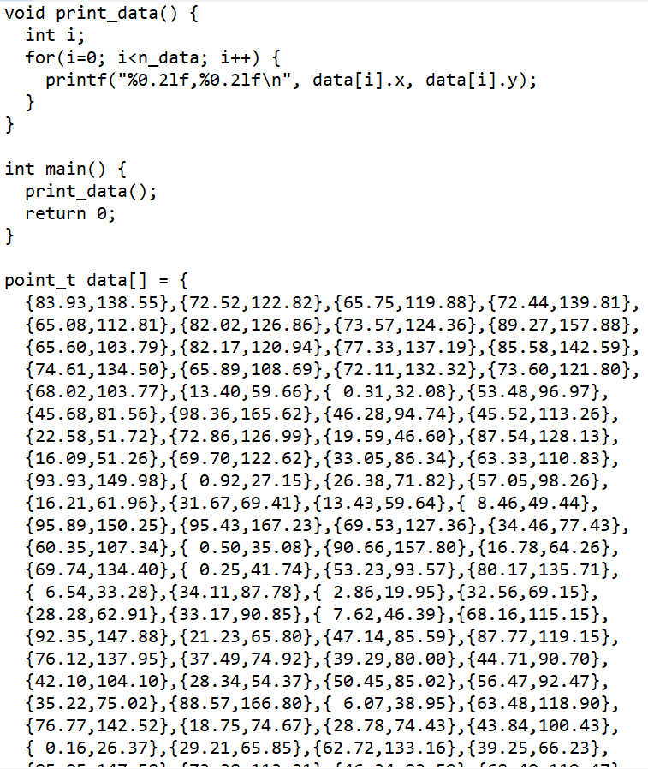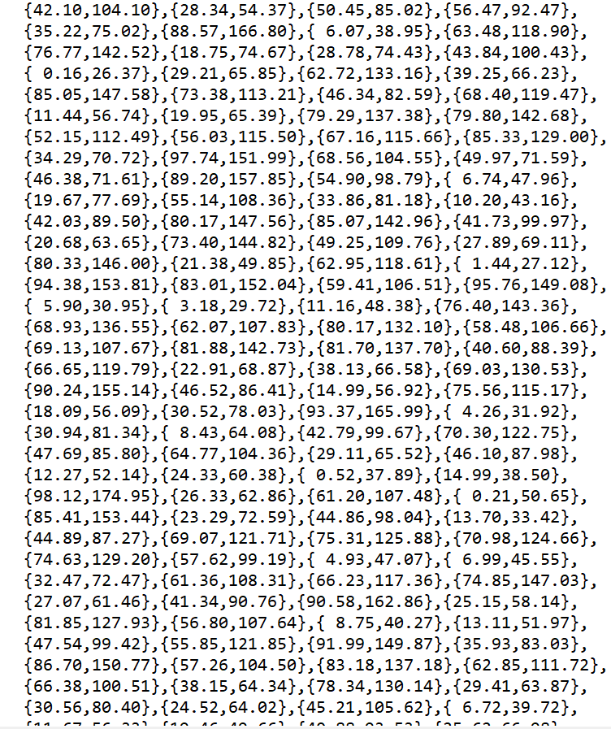

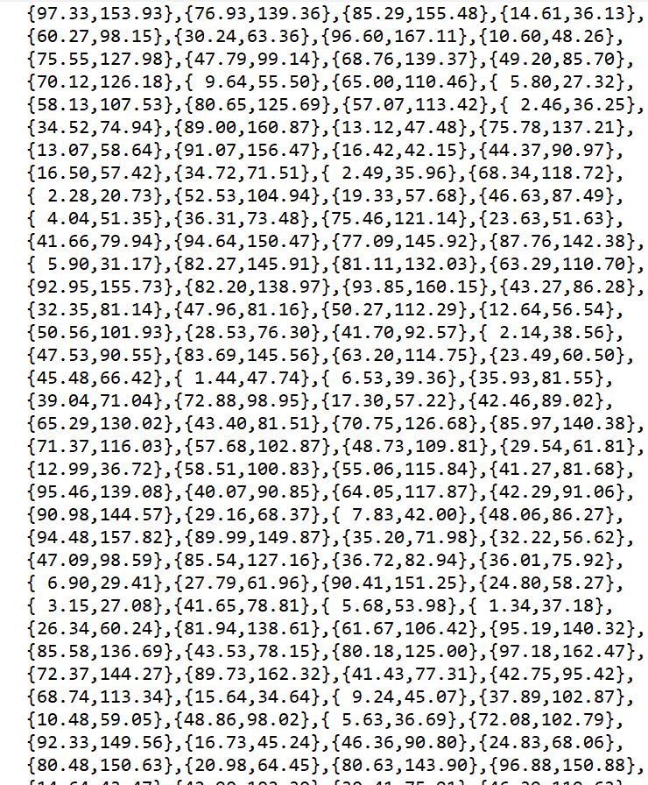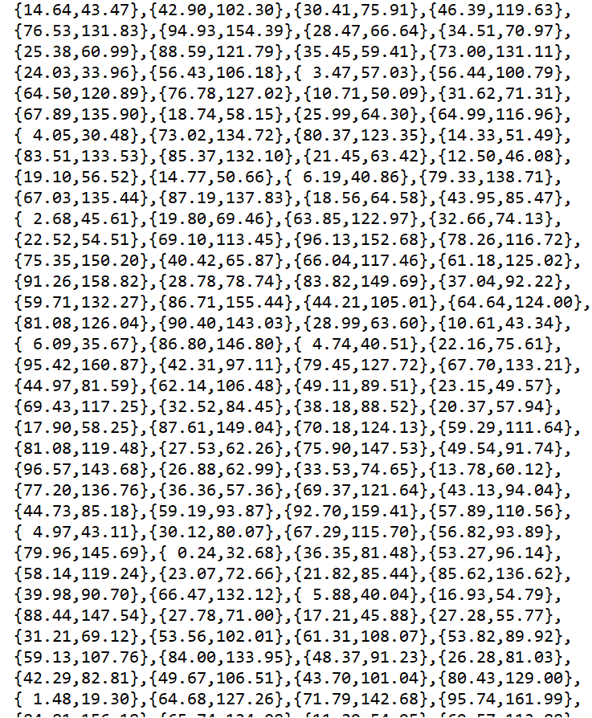

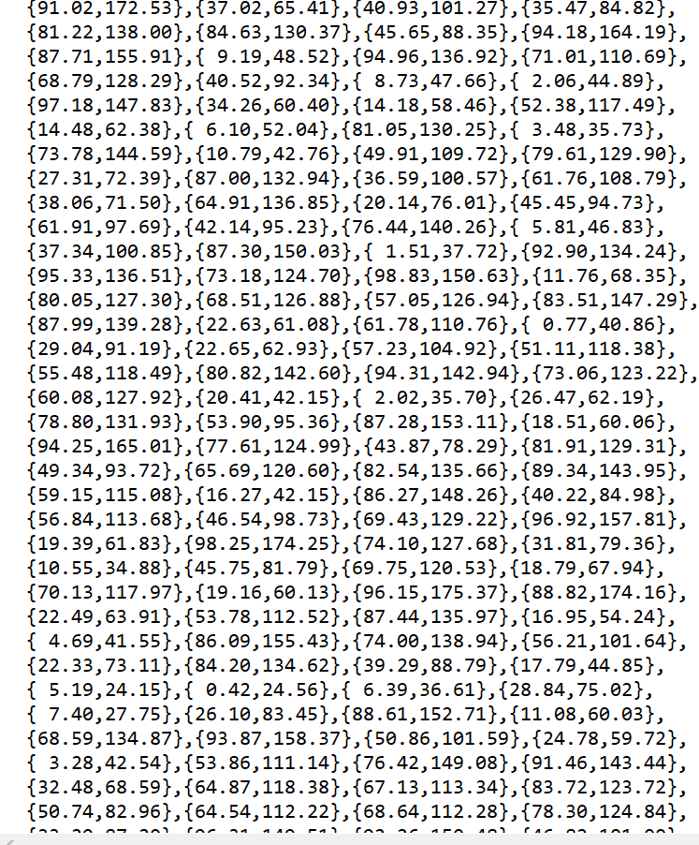 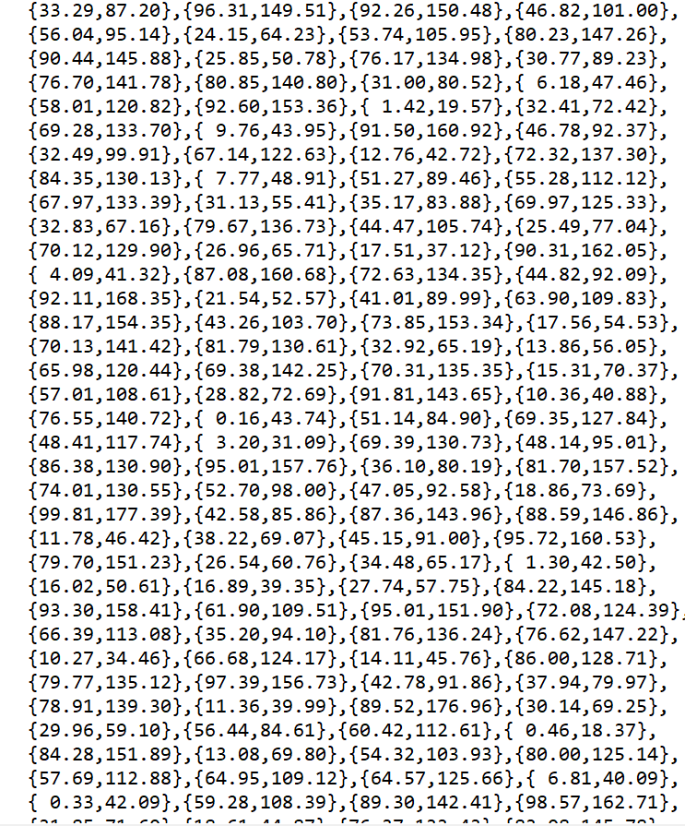

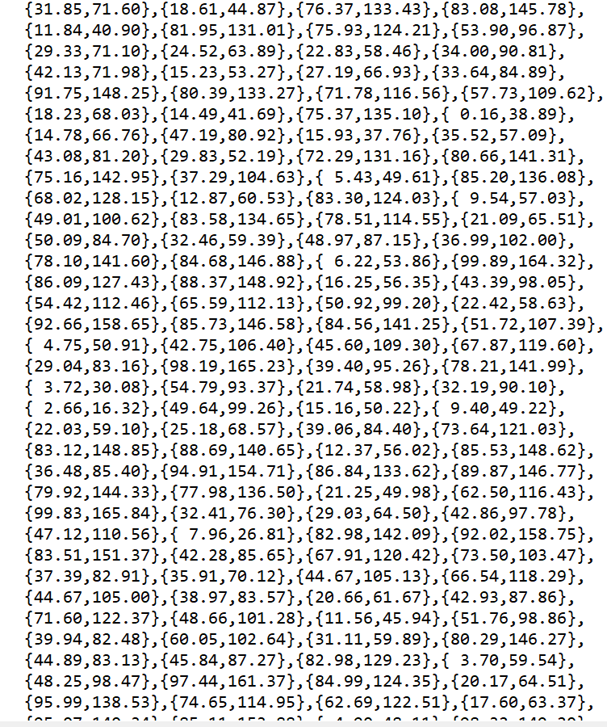 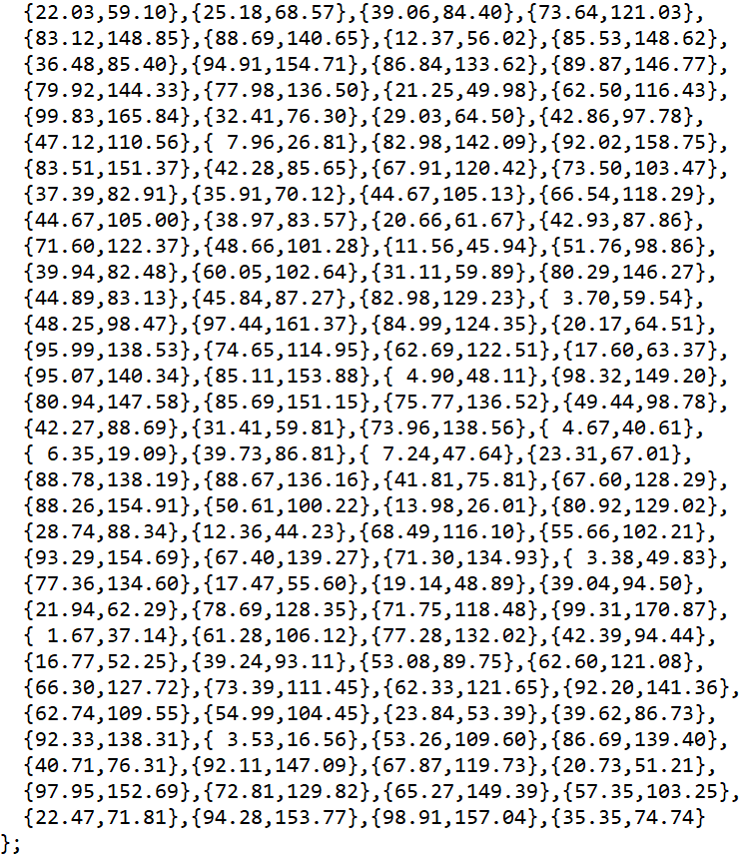

b.

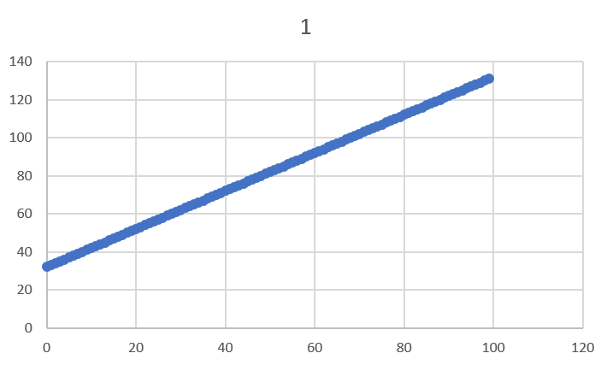

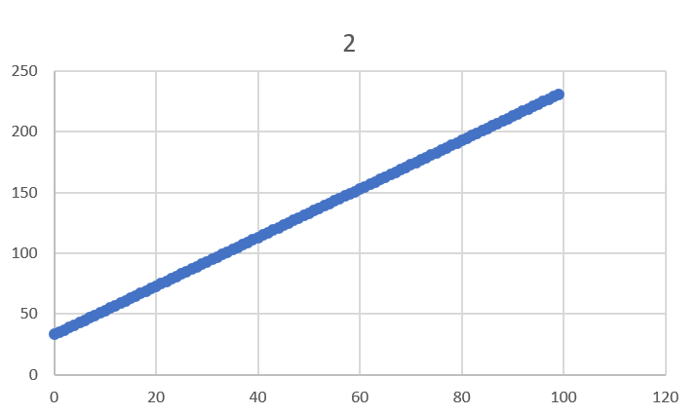

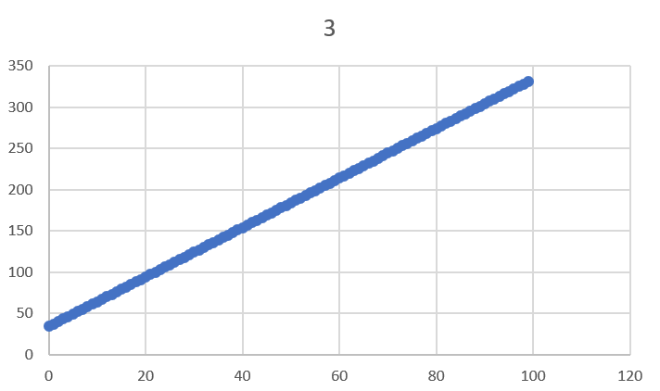

**Source Code:**

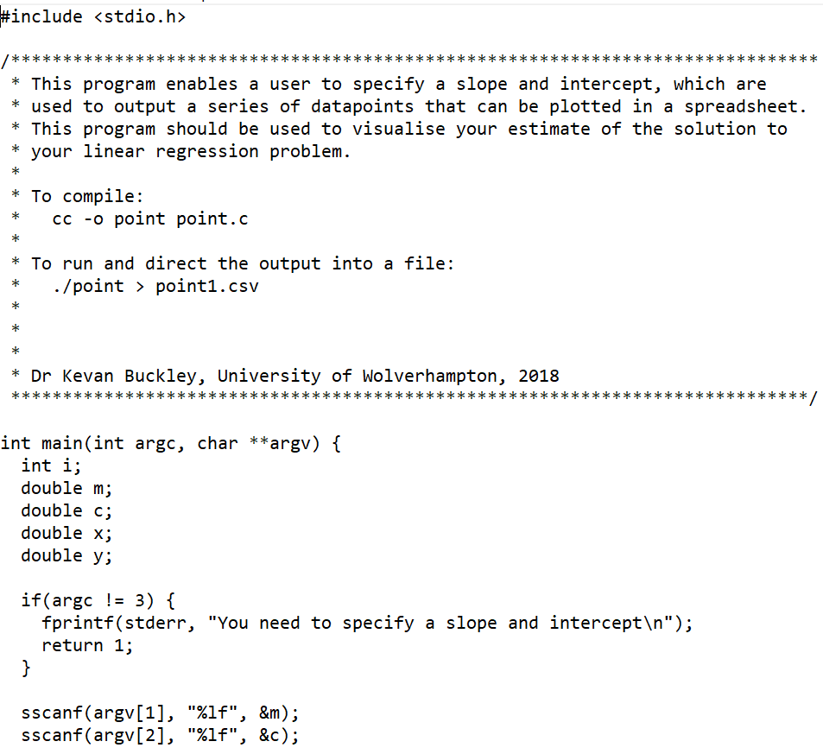

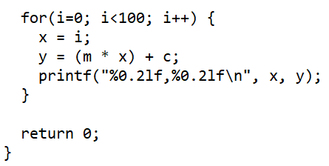

c.

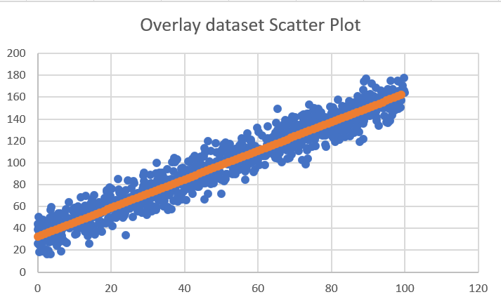

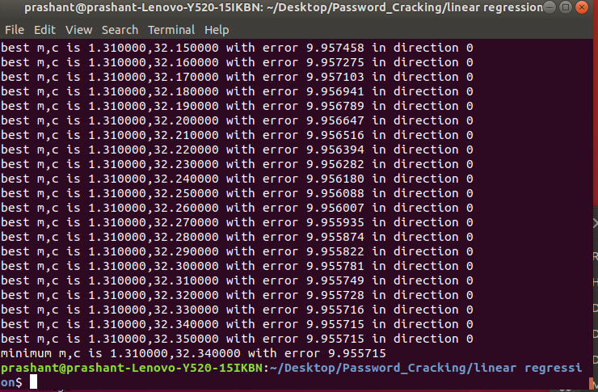

**Source Code:**

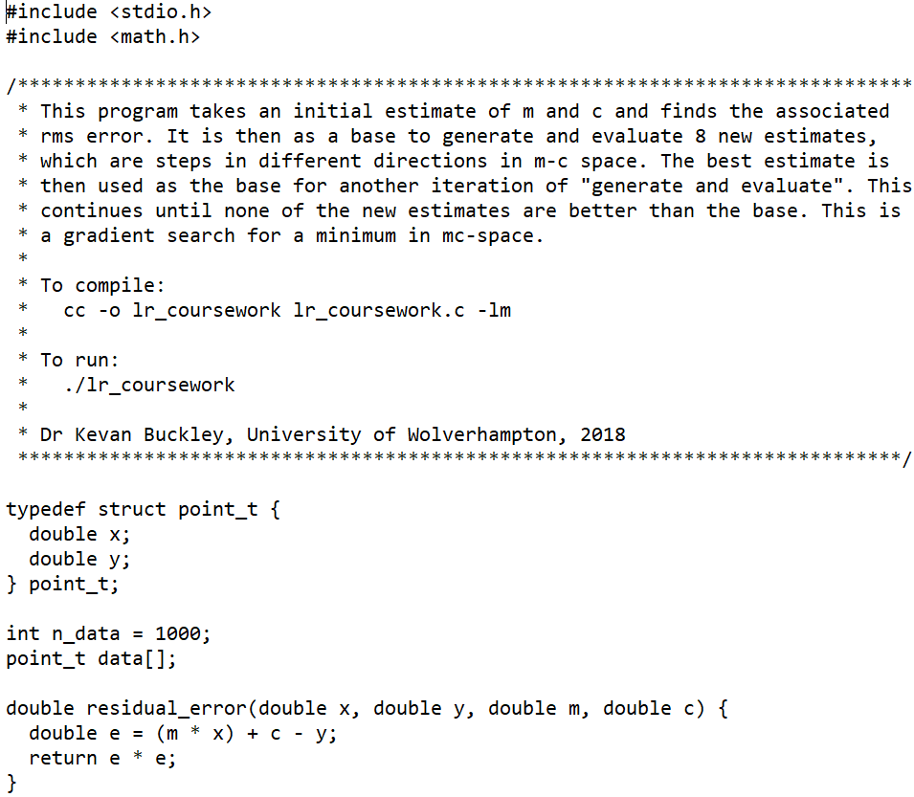

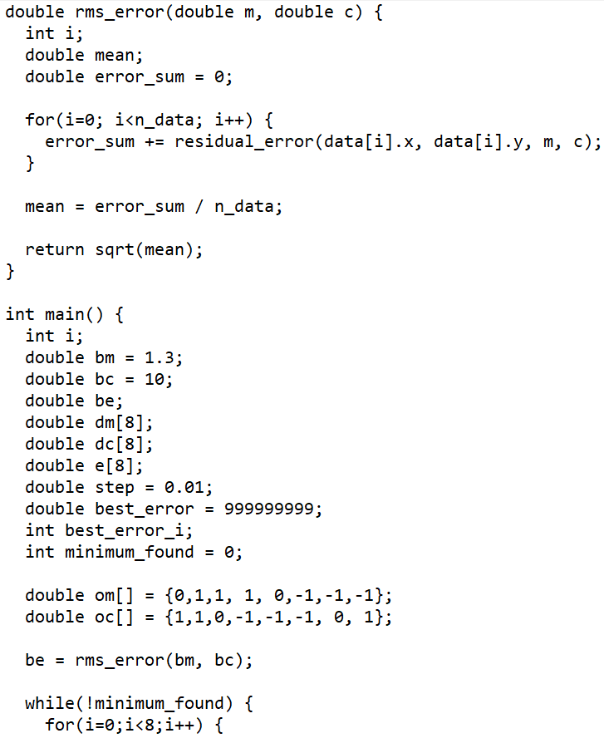

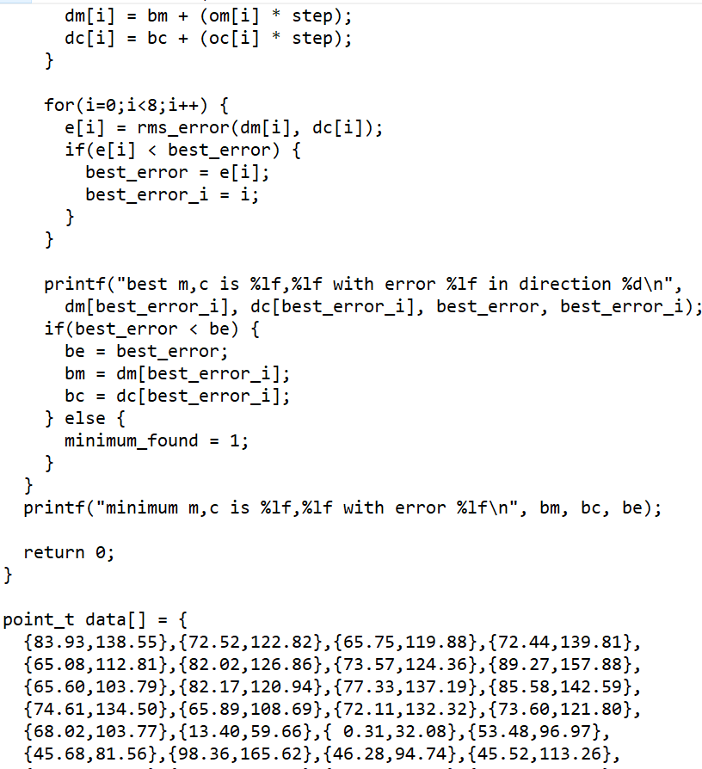

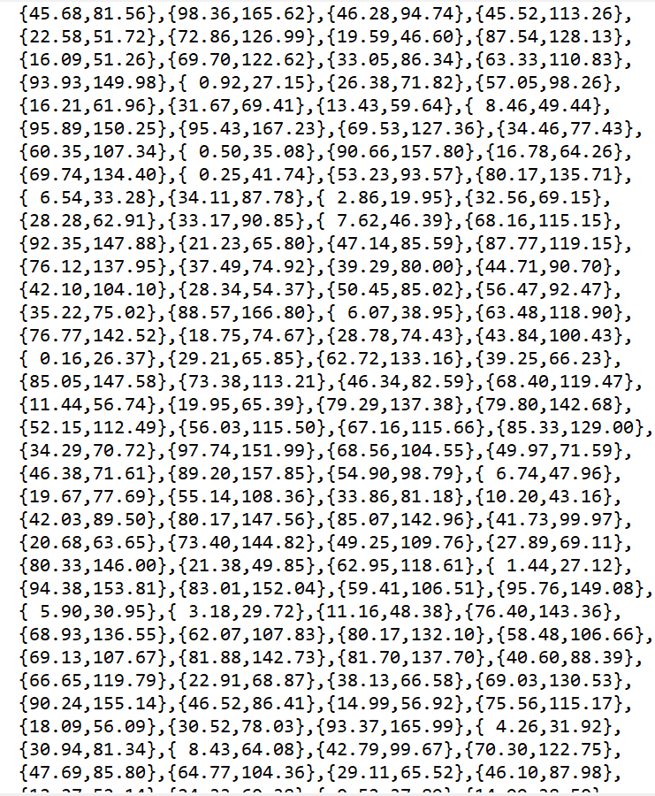

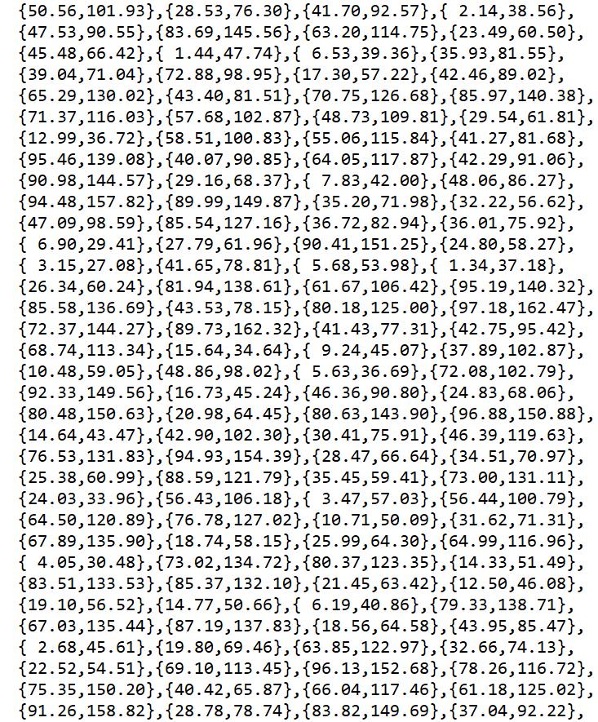 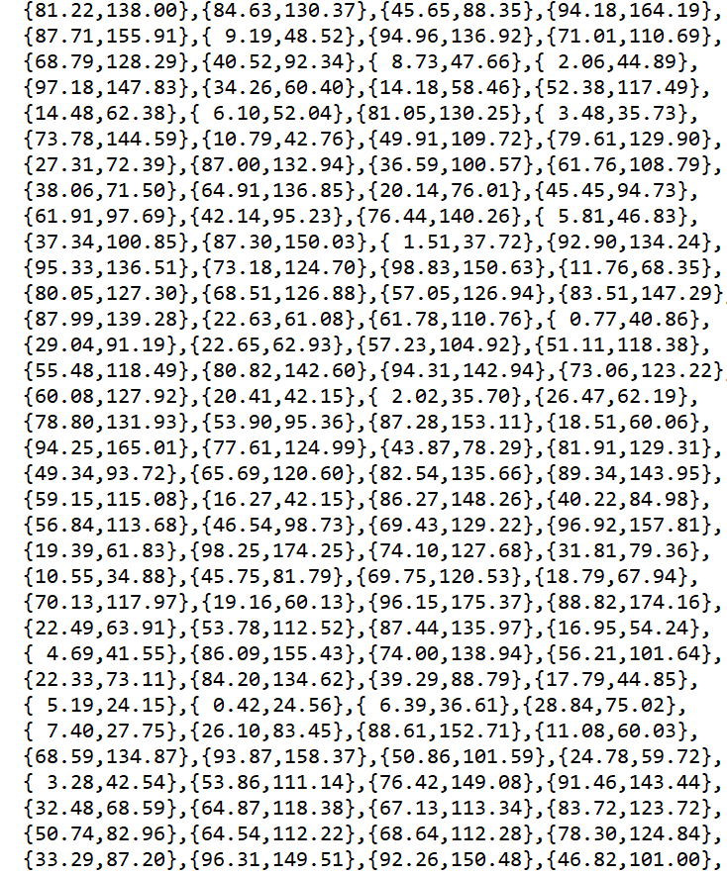

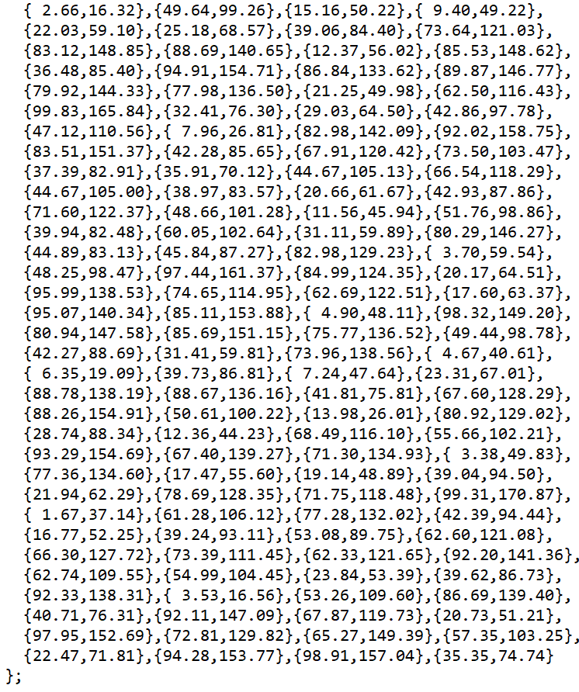

d. 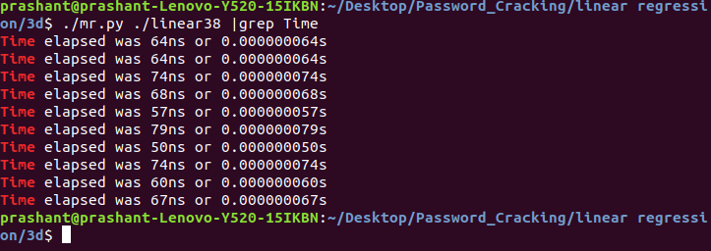

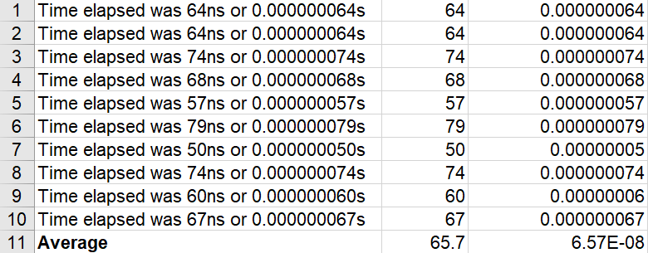

**Source Code:**

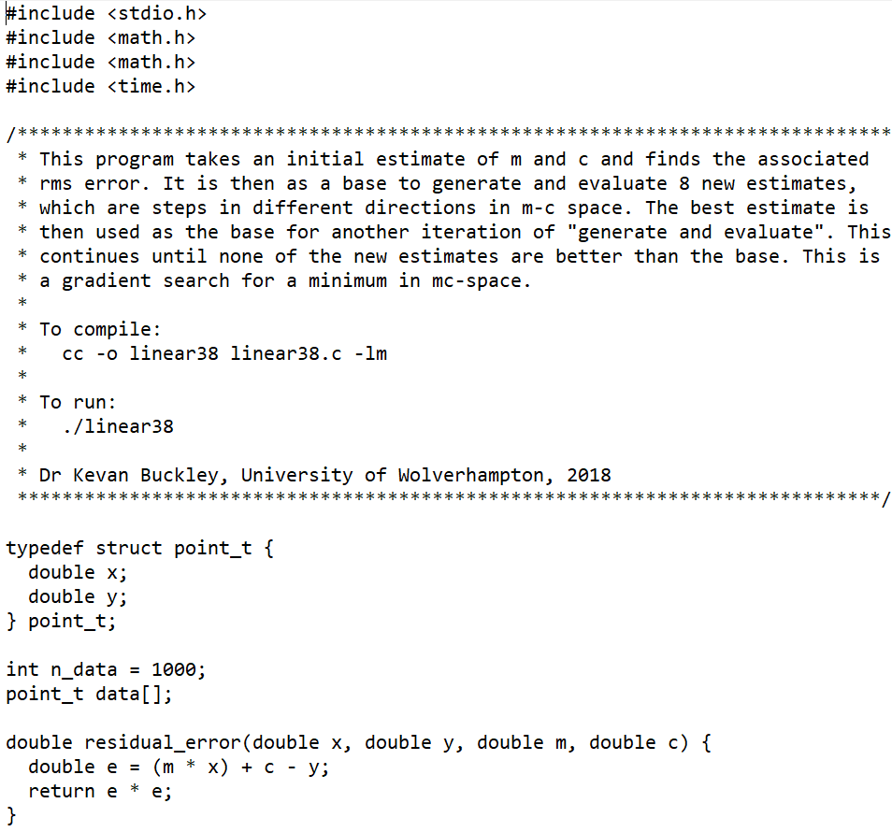

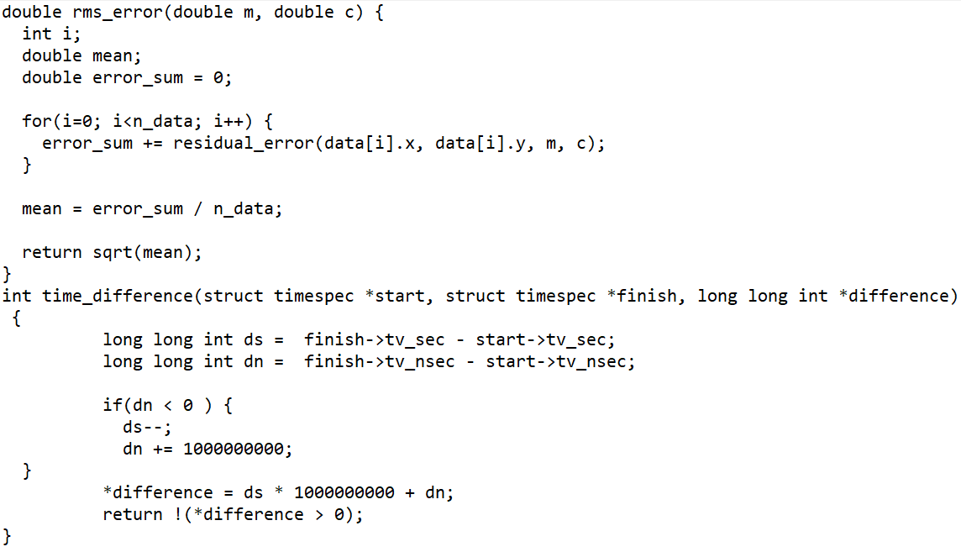

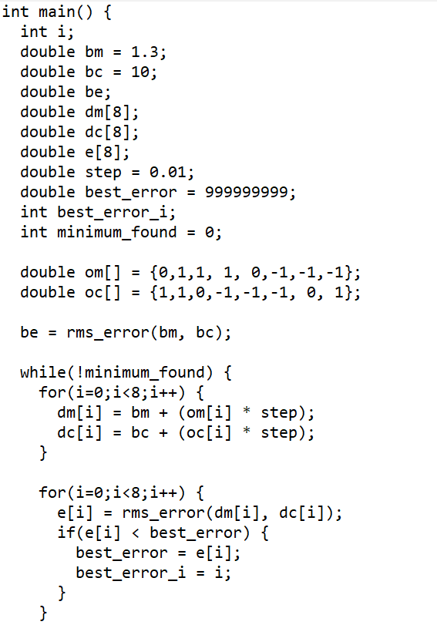 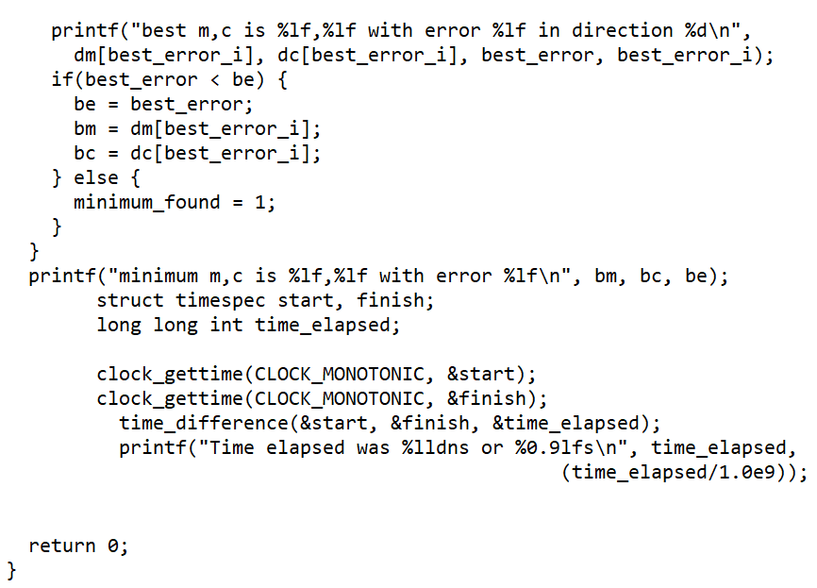

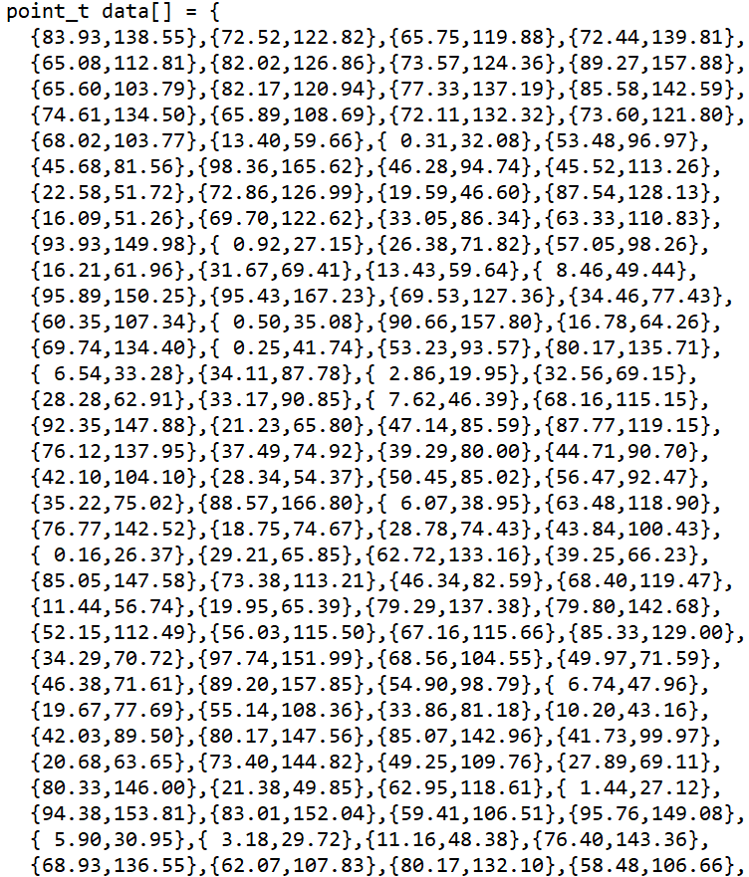



f. 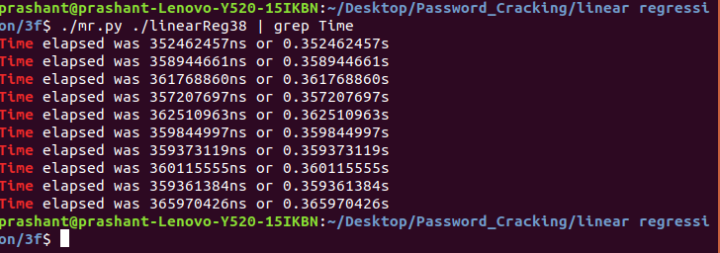

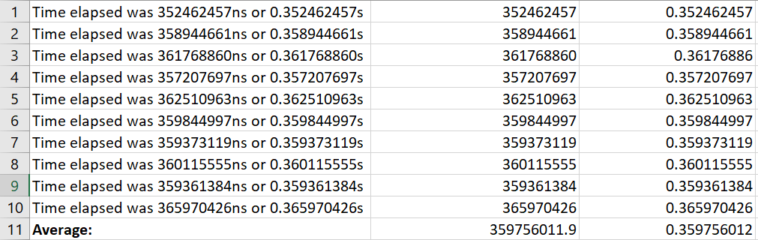

Write a short analysis of the results:

Linear regression means finding the line equation that best models a set of data points. Comparing the table above, we found that the time taken for multi-threading software takes a long time compared to the simple linear regression method. Here the time taken by the original program is 67 ns, whereas the program takes 365970426ns after the loop has been applied. This is because there are 8 threads and only 4 main threads to work on. There has been more pressure to complete the little work and the threads spend time waiting for each other to complete.

# **2. CUDA**

## **2.1. Password Cracking**

Compiling and Running the program:

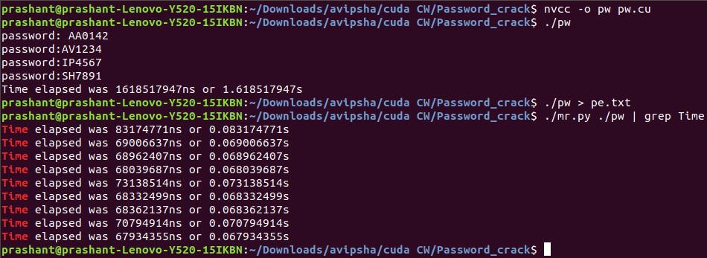

**Source Code:**

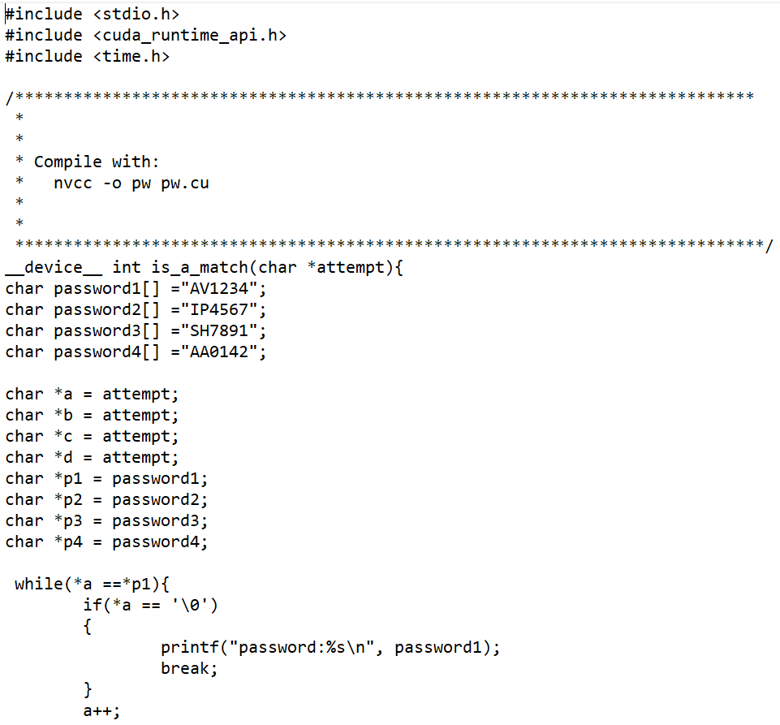

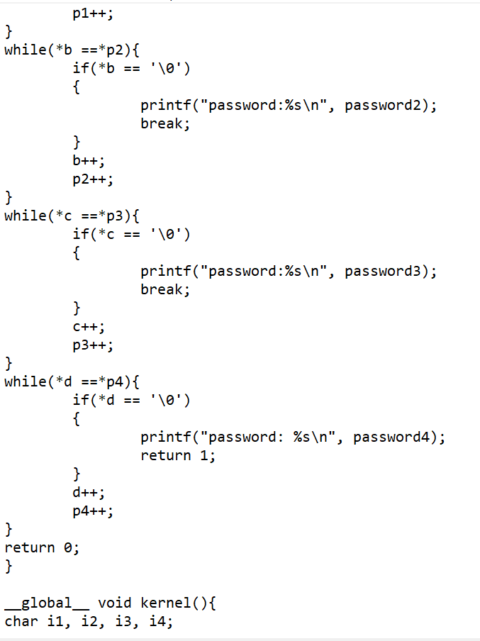

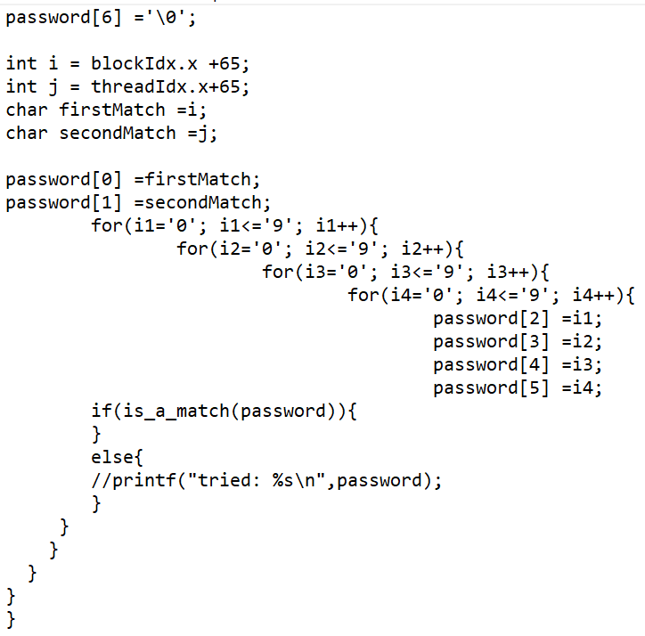

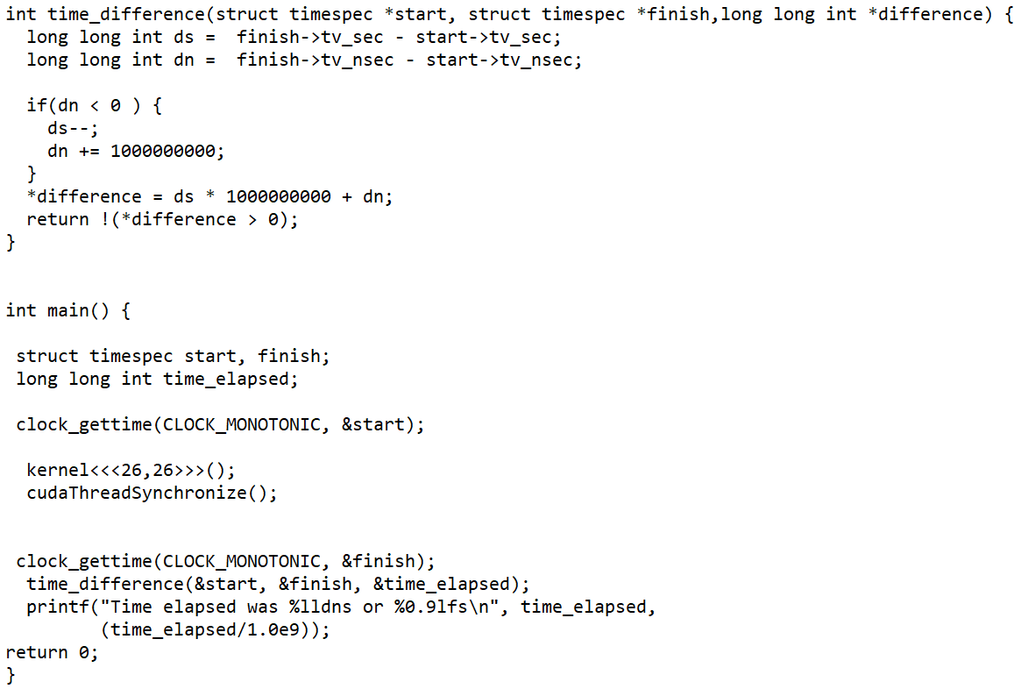

Time taken to Execute the program:

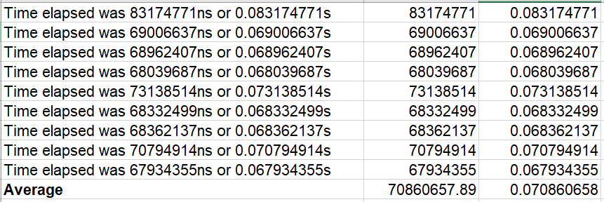

The table above shows the mean runtime of the password cracking version of both simple and CUDA. Simple program includes 2 alphabets and 2 digits whereas 2 alphabets and 4 digits are included in the CUDA program. By comparing the table, we agree to take that the average running time of CUDA program for cracking password is faster than the simple program. This is because the basic program runs on the CPU, but CUDA runs on GPU which has more cores than the CPU. GPU consists of multiple parallel running drives and quicker compared to CPU memory interfaces. It is therefore more efficient computationally. Average running time of simple program is 572 sec and CUDA program is 0.07 sec.

## **2.2. Image Processing**

Compiling and Running the Program:

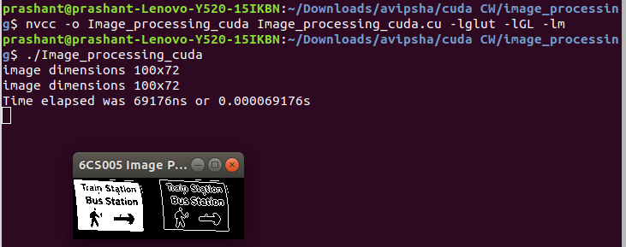

Running the Program Ten times:

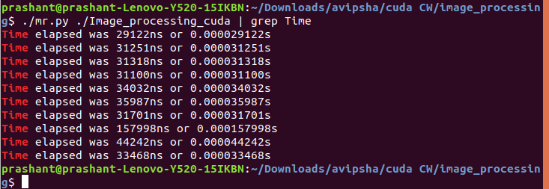

**Source Code**

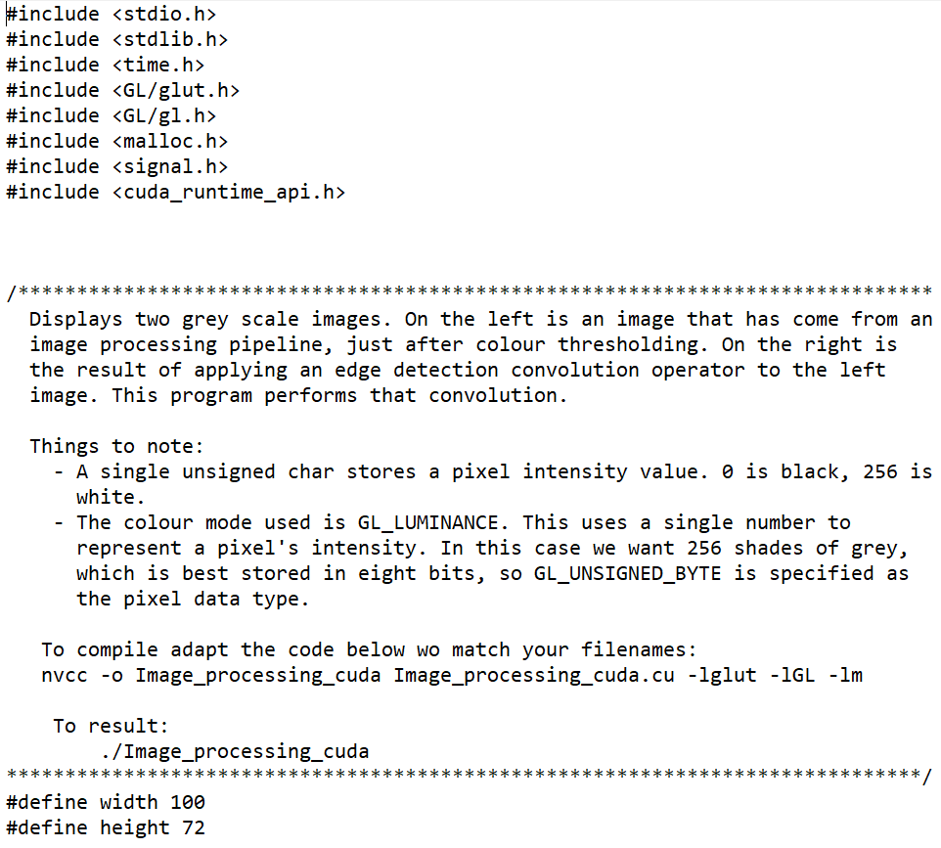

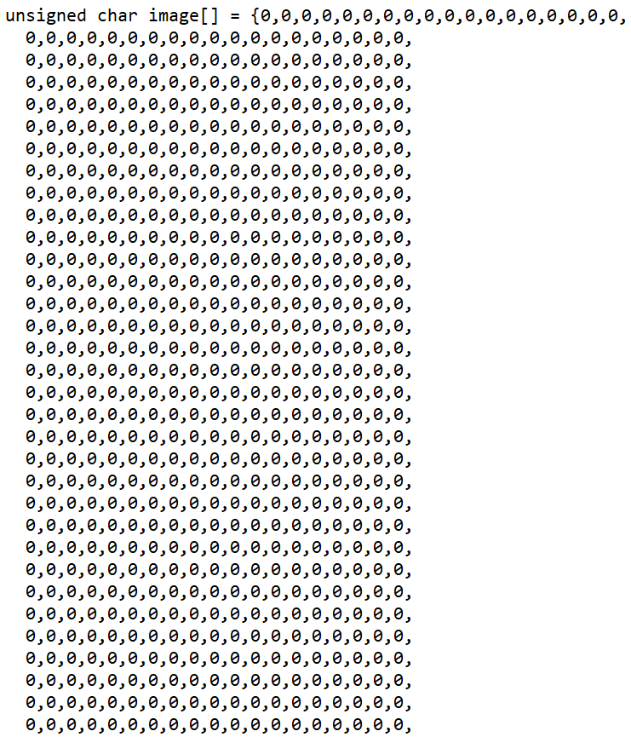

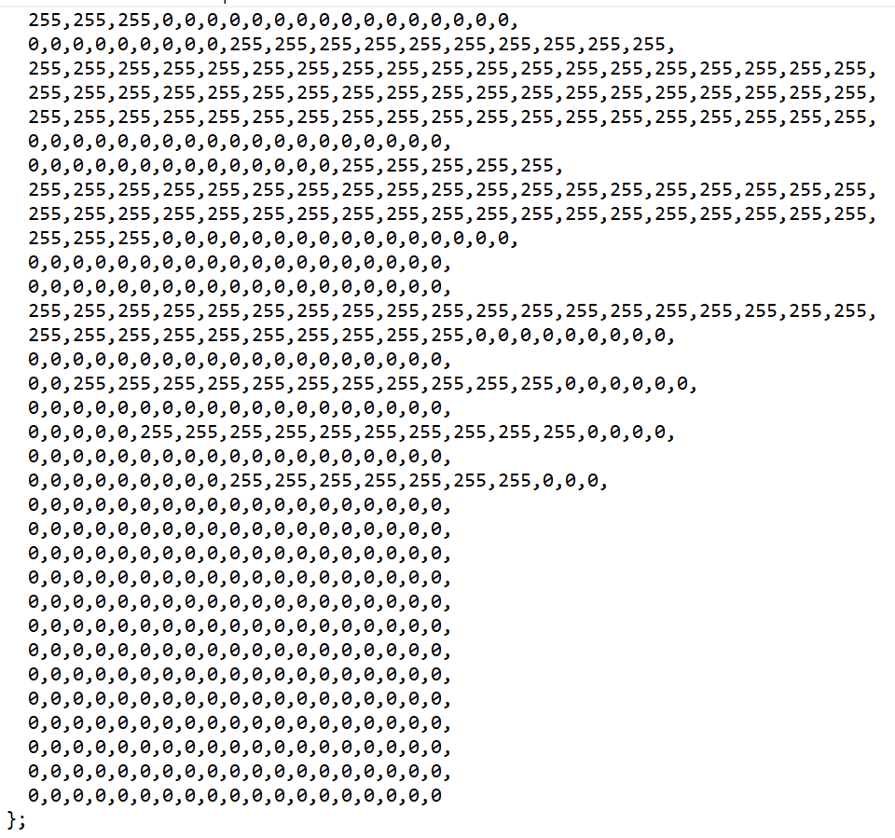

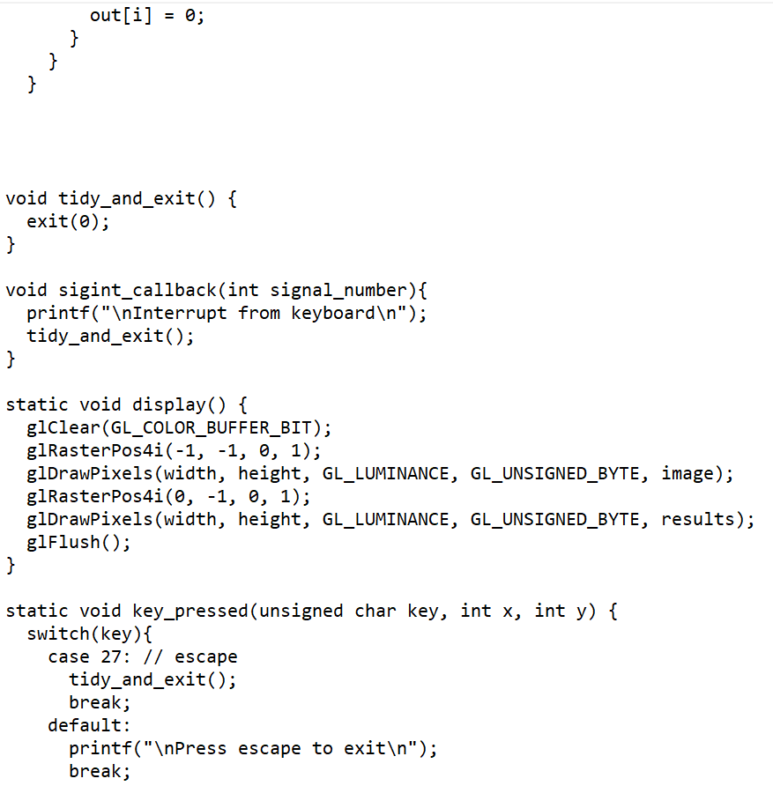

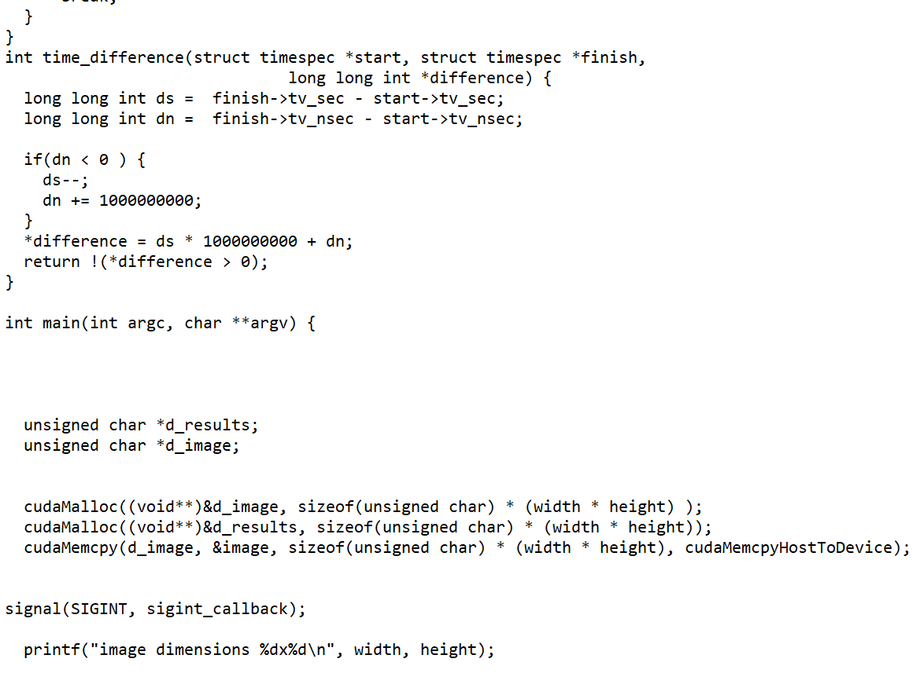

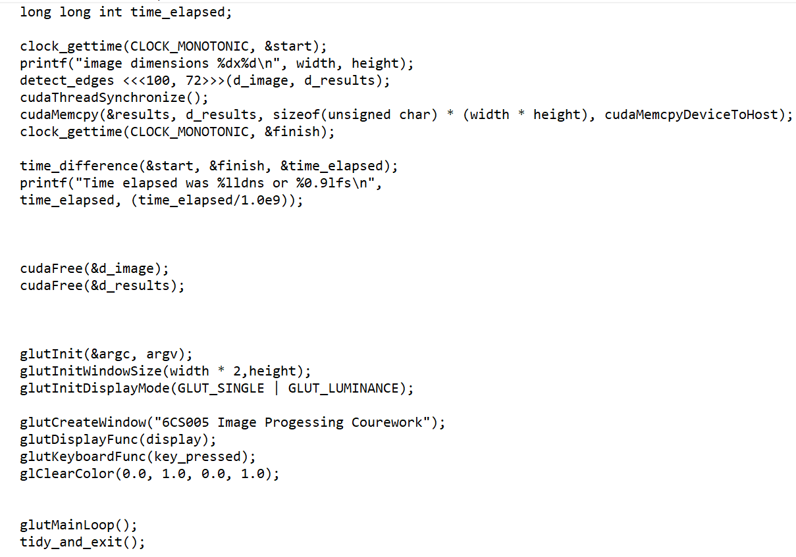

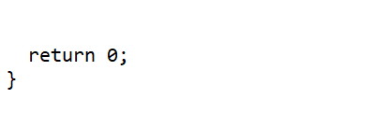

Time taken to Execute the Program:

 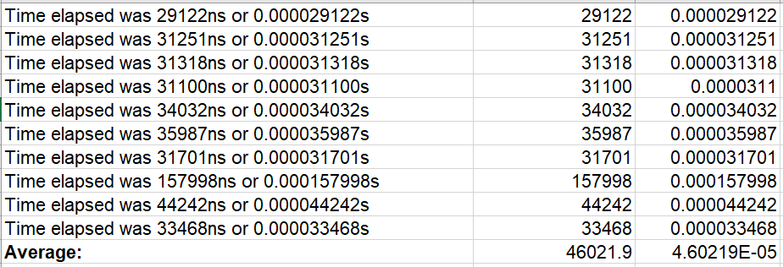

Write a short analysis of the results:

The table above shows the mean runtime of a simple program and a CUDA program for image processing. The mean runtime for the original version was 170.9ns, while the mean runtime for the CUDA program was 46021.9ns. The difference was 45851ns between them. In this case, we find that programs running in GPU is slower than the one running in CPU. This is because the image data should be managed by the device type host and the program is executed in the device. After execution, the data should be passed to the display host again, making programs run slow on CUDA.

## **2.3 Linear Regression**

Compiling and Running the Program:

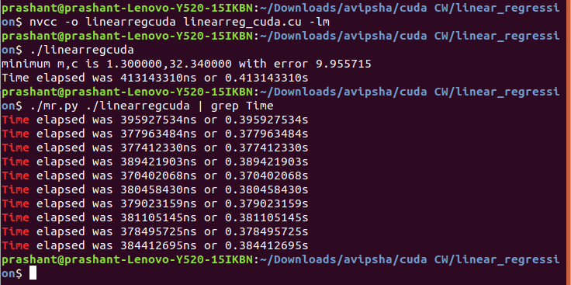

**Source Code**

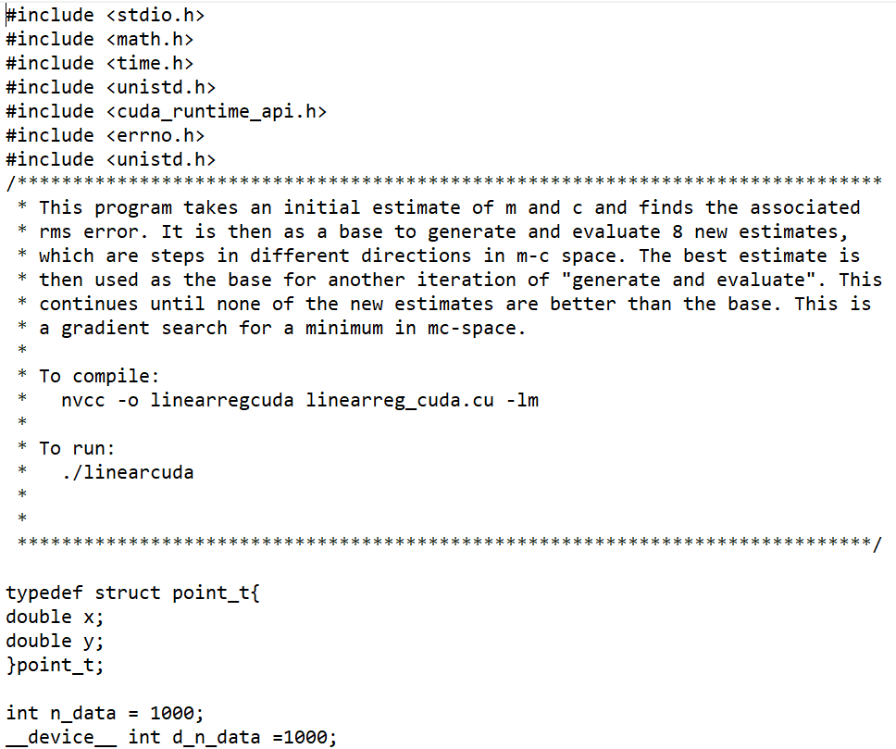

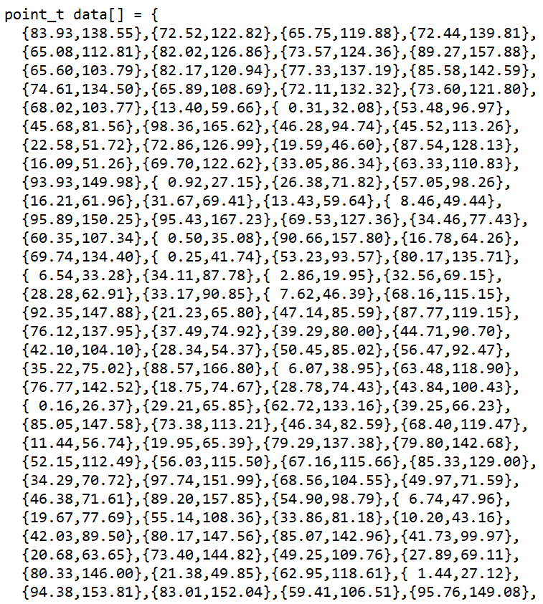

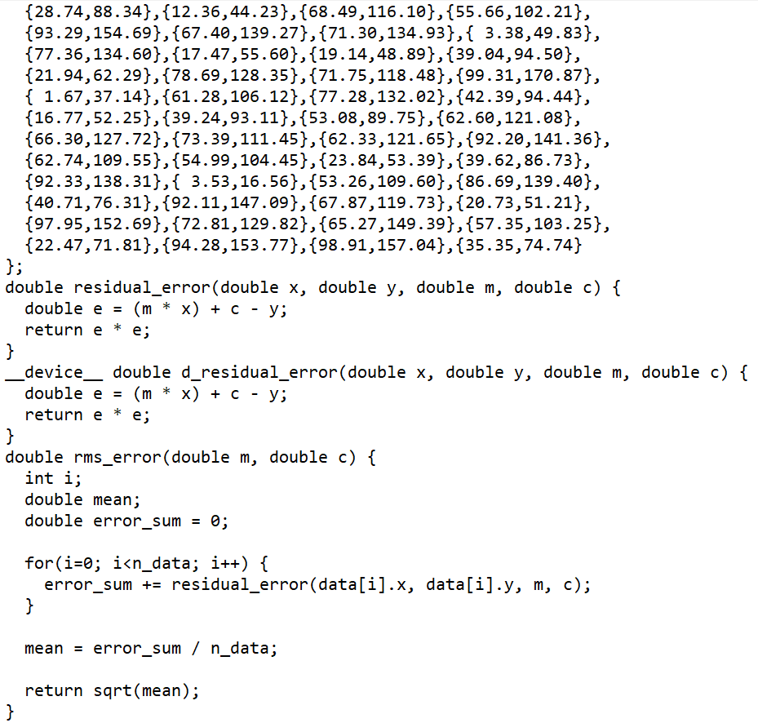

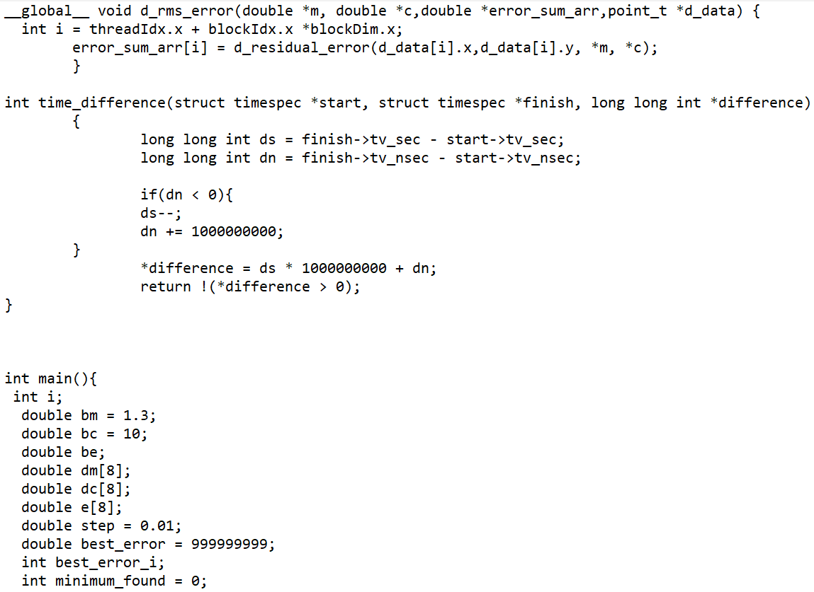

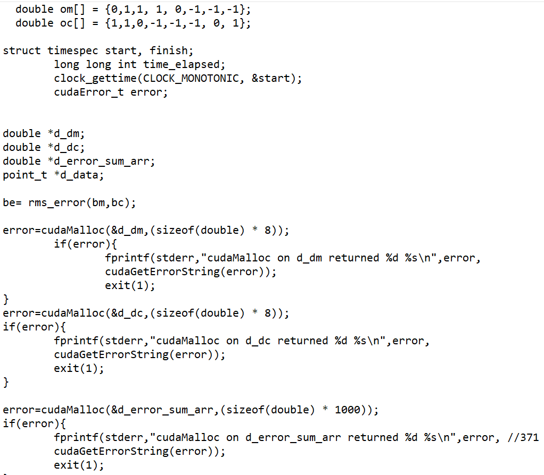

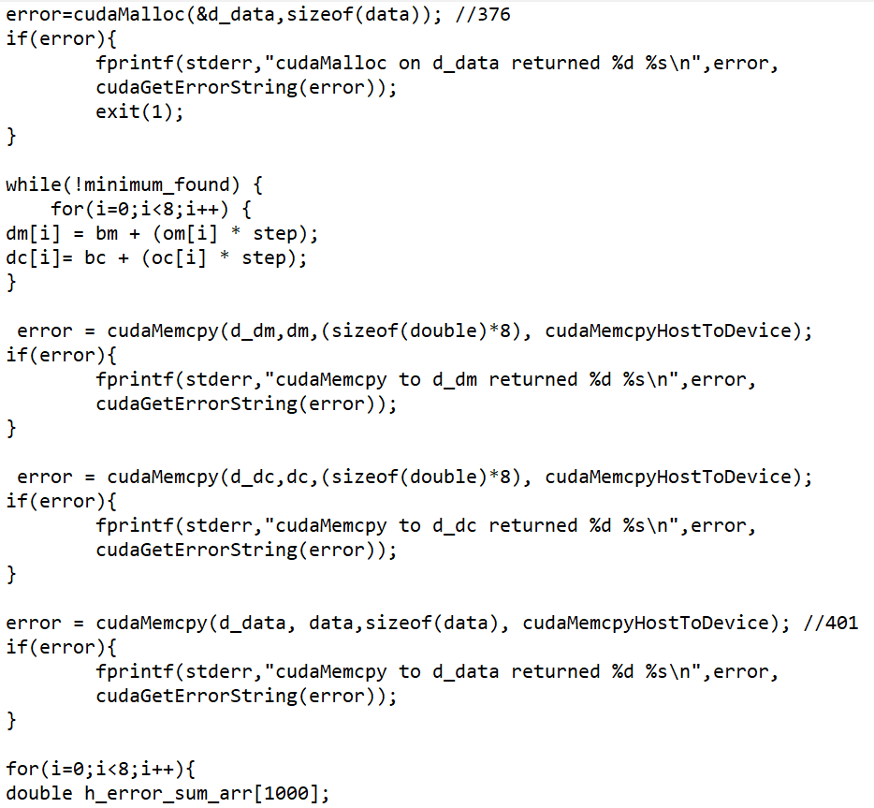

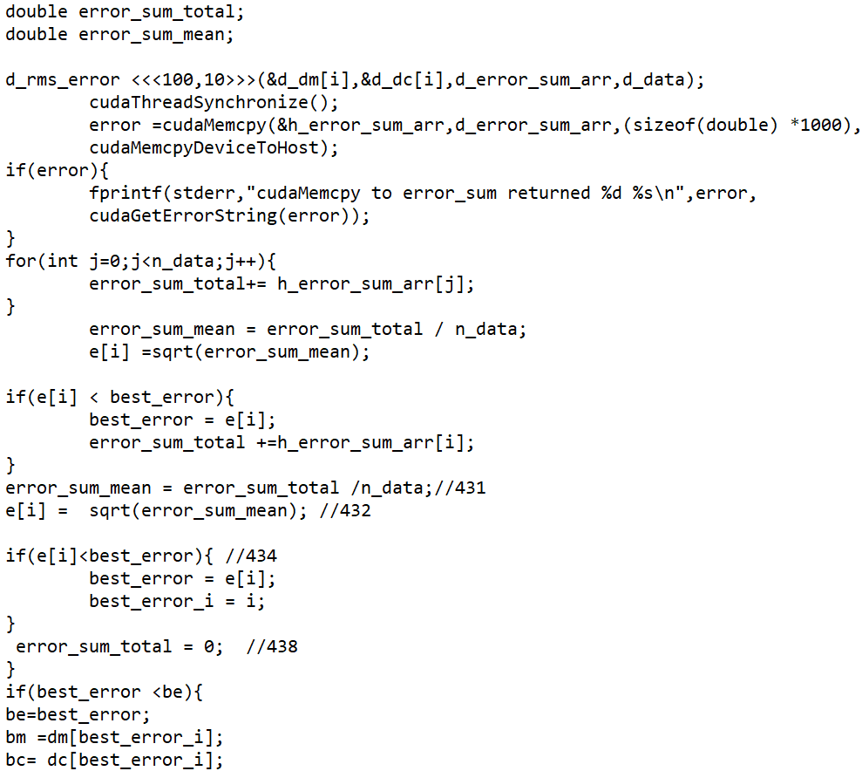

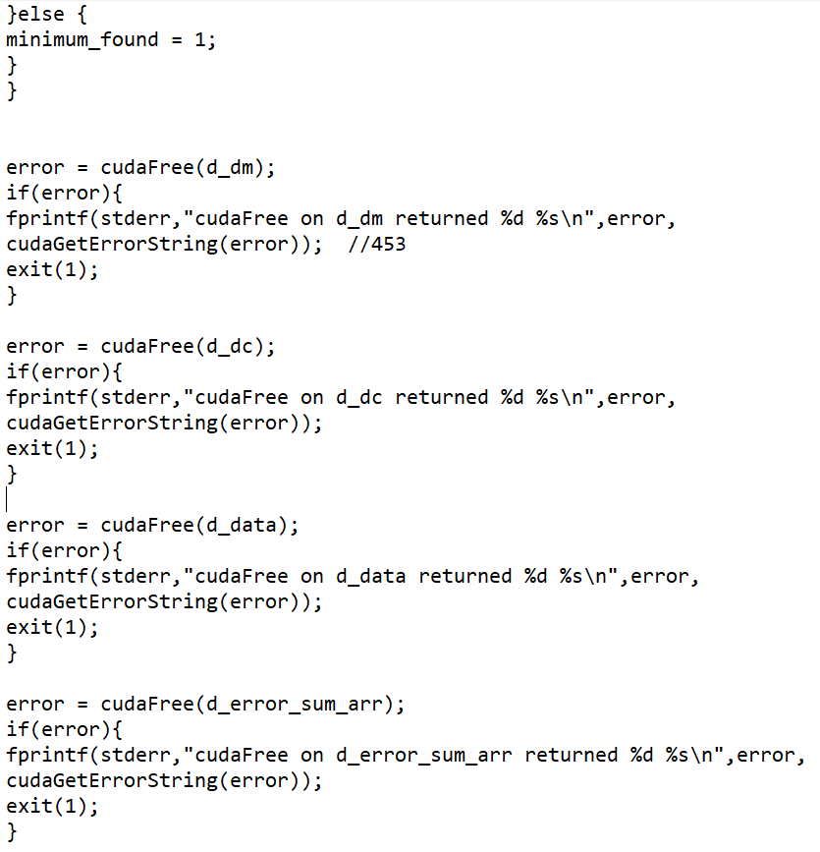

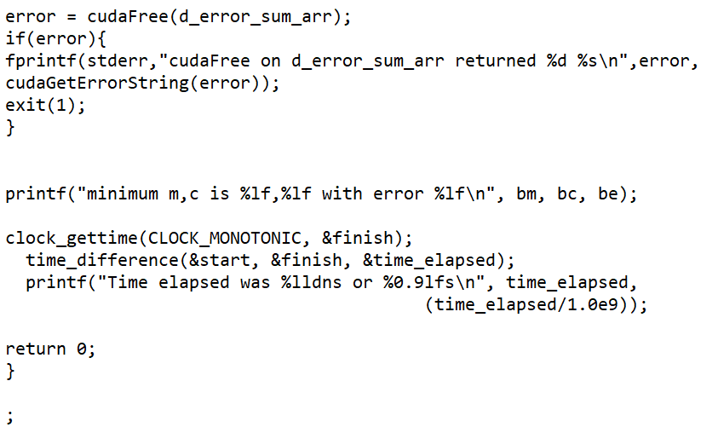

Time taken to Execute the Program:

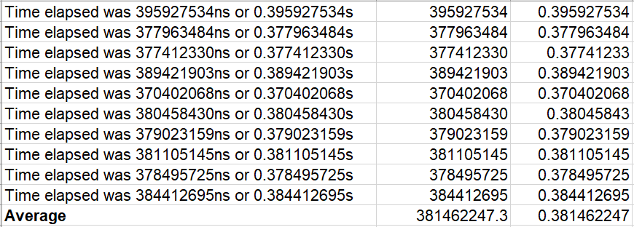

Comparing:



The table above shows the mean runtime of the linear regression system and CUDA edition. The average running time of the linear program running in CPU is 65.7 ns 381462247.3 ns is the CUDA program running in GPU. The program running in the CPU is evidently faster than the program running in the GPU. The program in GPU takes more time to copy the data from CPU to GPU while it requires minimal time when doing this in the CPU version as the program itself is very small.

# **Message Passing Interface**

## **Password Cracking**

Running the program one time and analysing the required time

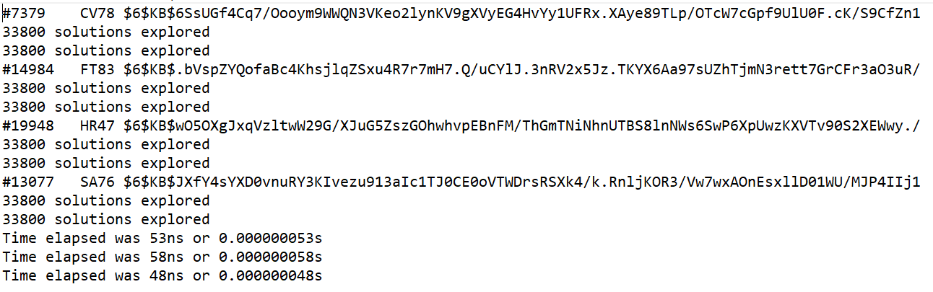

**Source Code:**

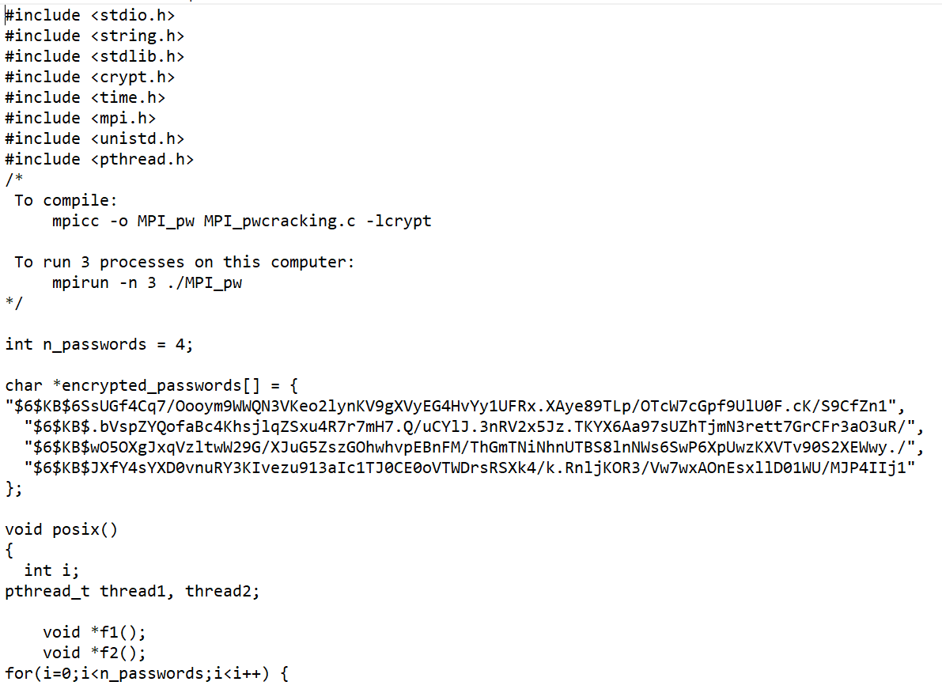

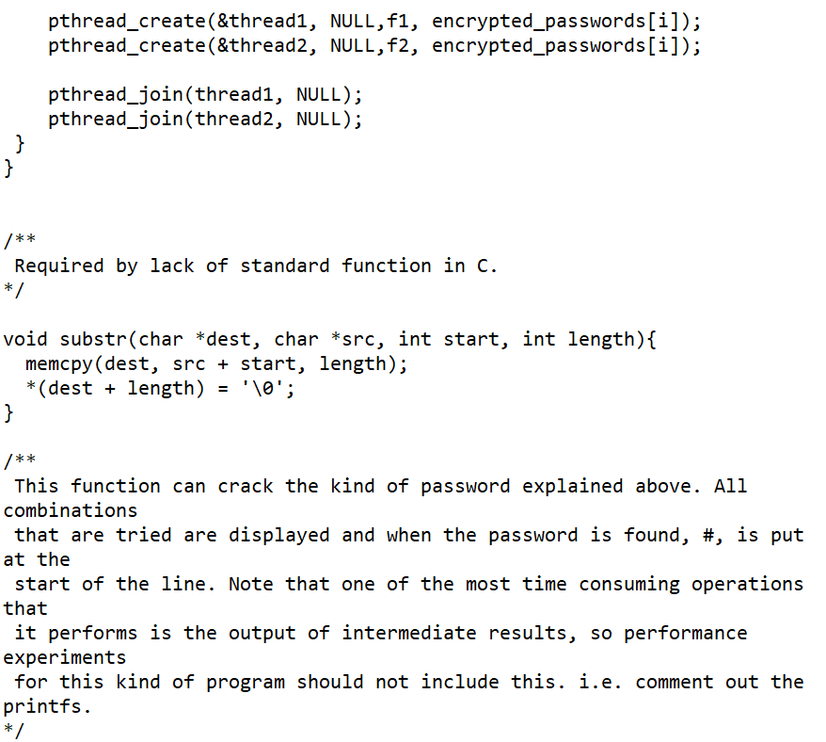

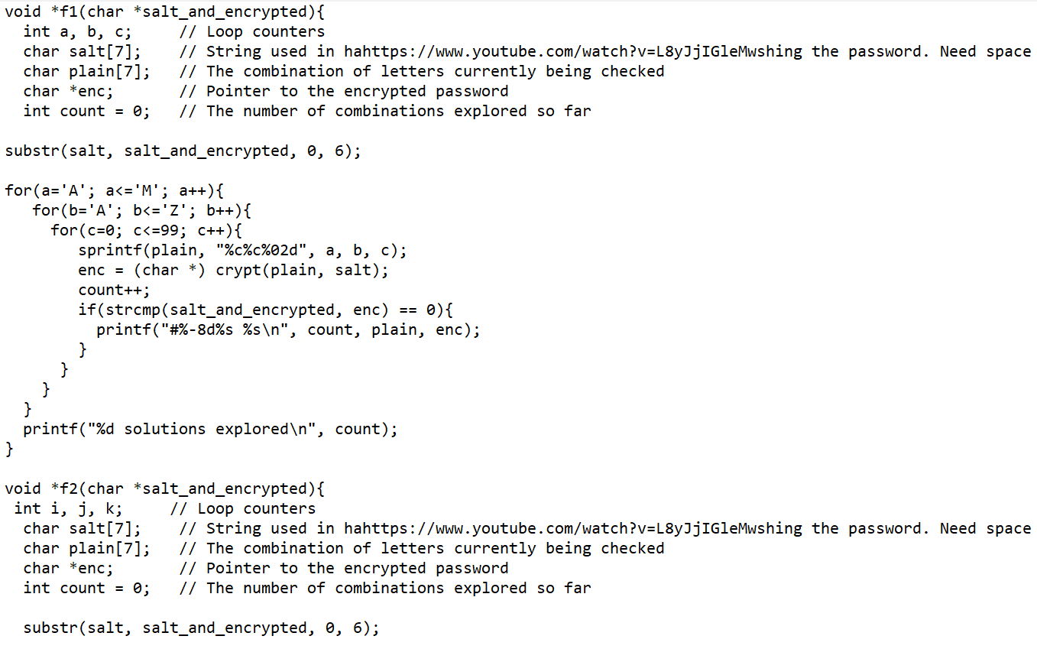

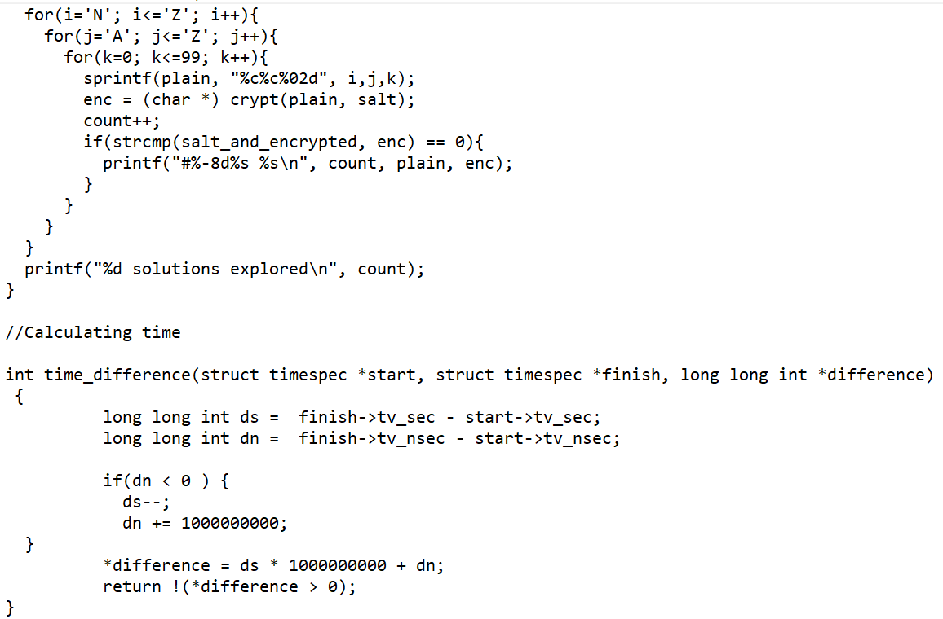

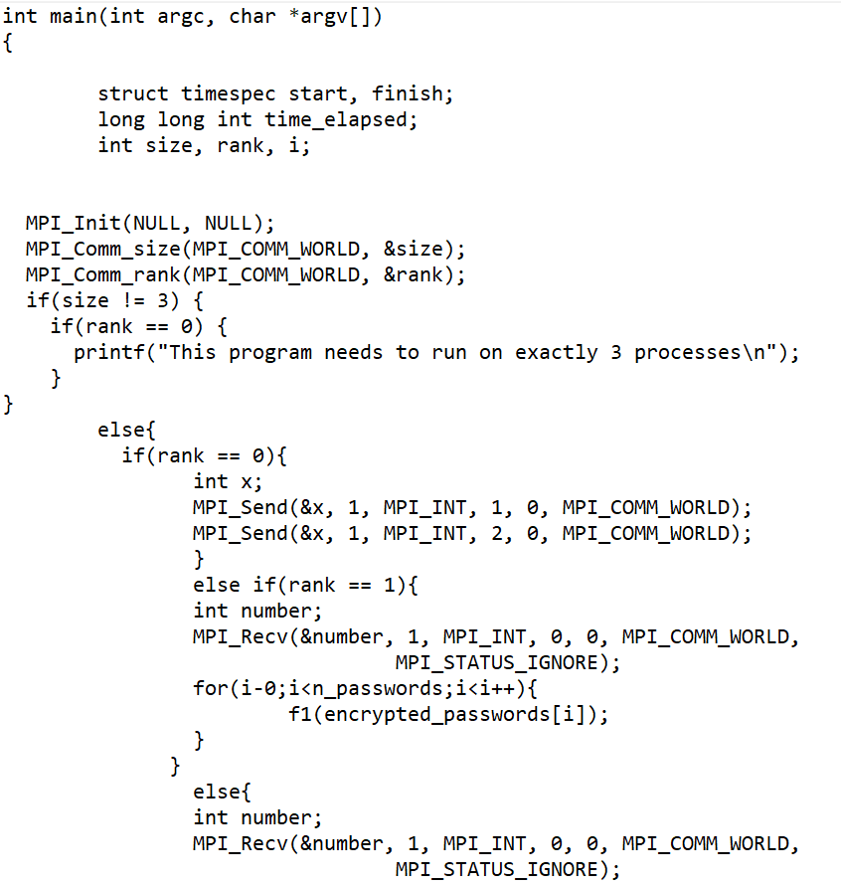

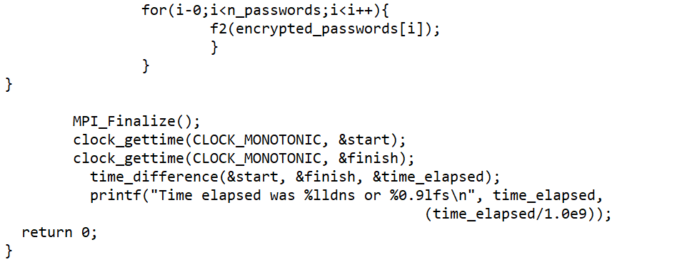

Compiling and running the program ten times:

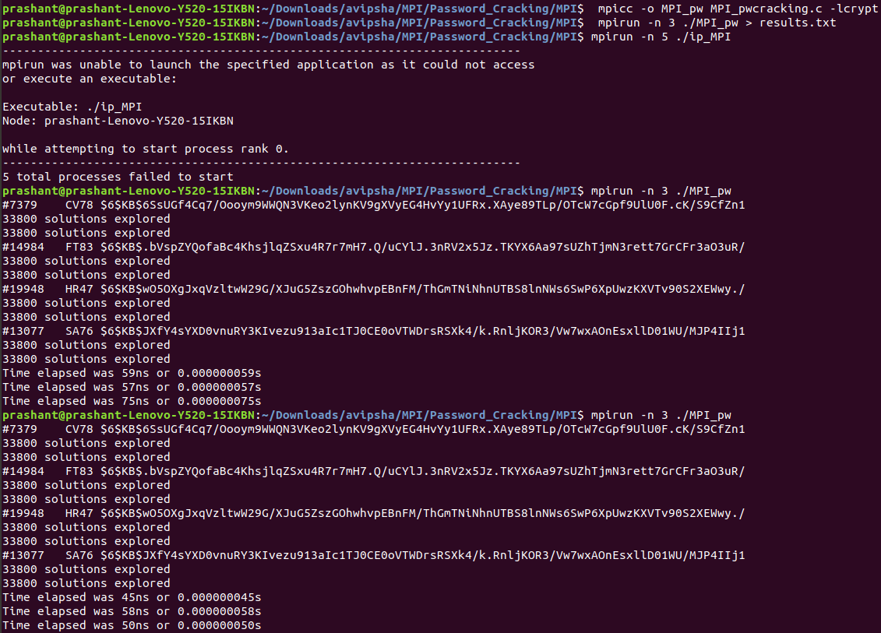

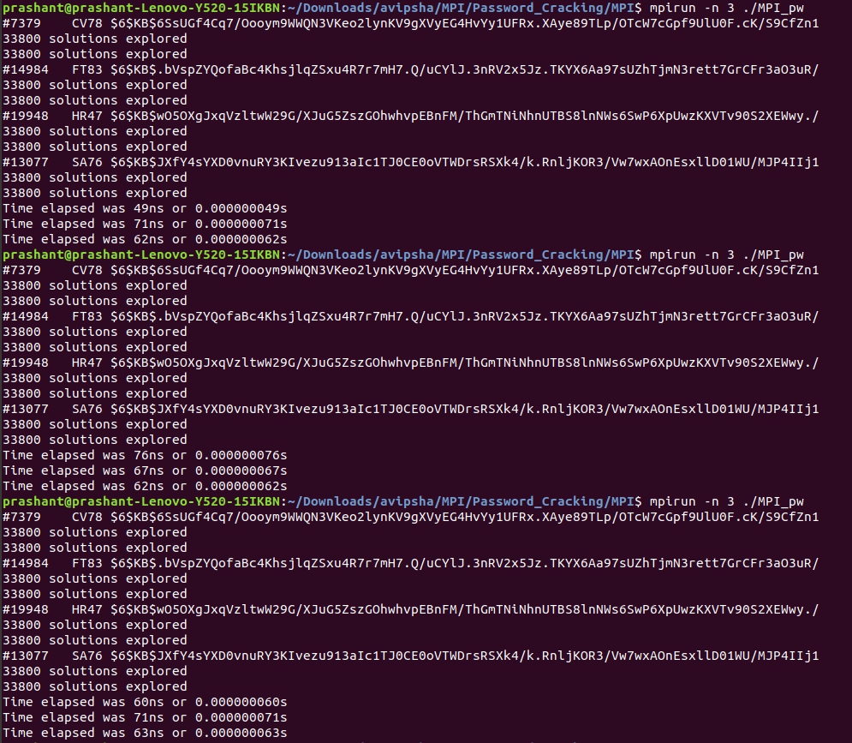

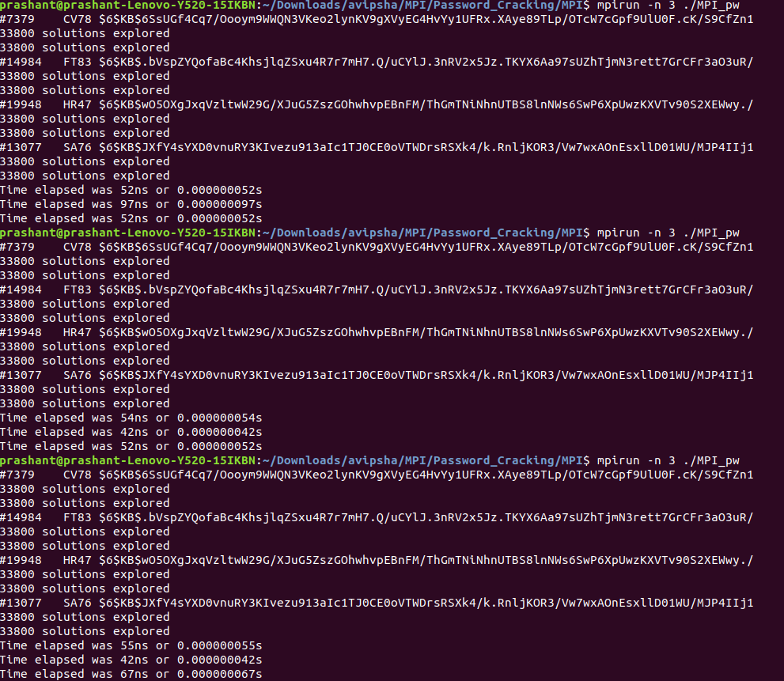

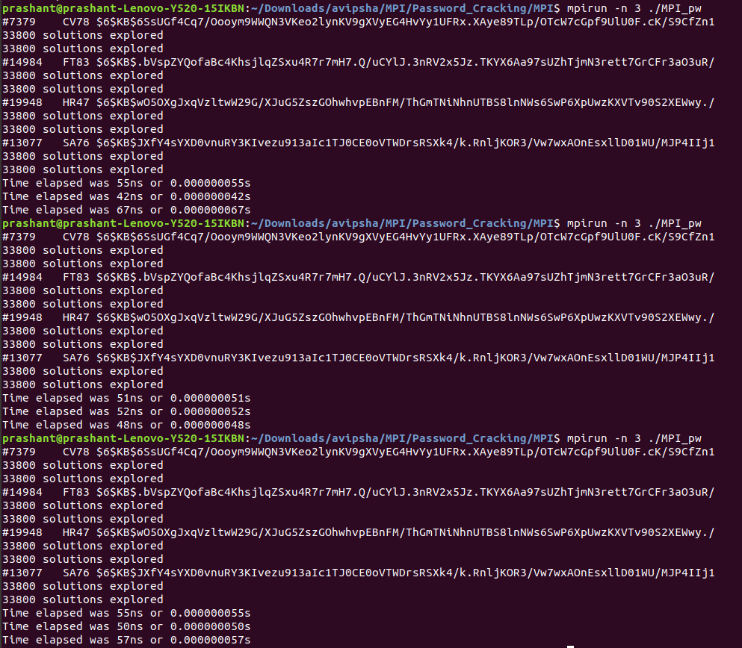

Calculating the average of the time required to execute the program:

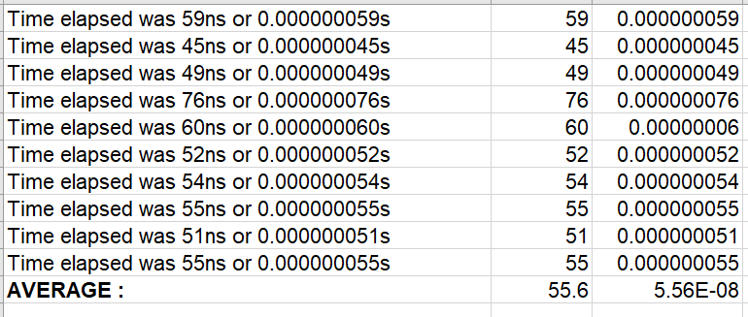

Insert a table that shows running times for the original and MPI versions.



## **Image Processing**

Compiling and running the program:

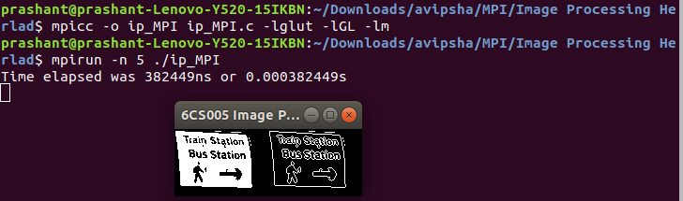

**Source Code**

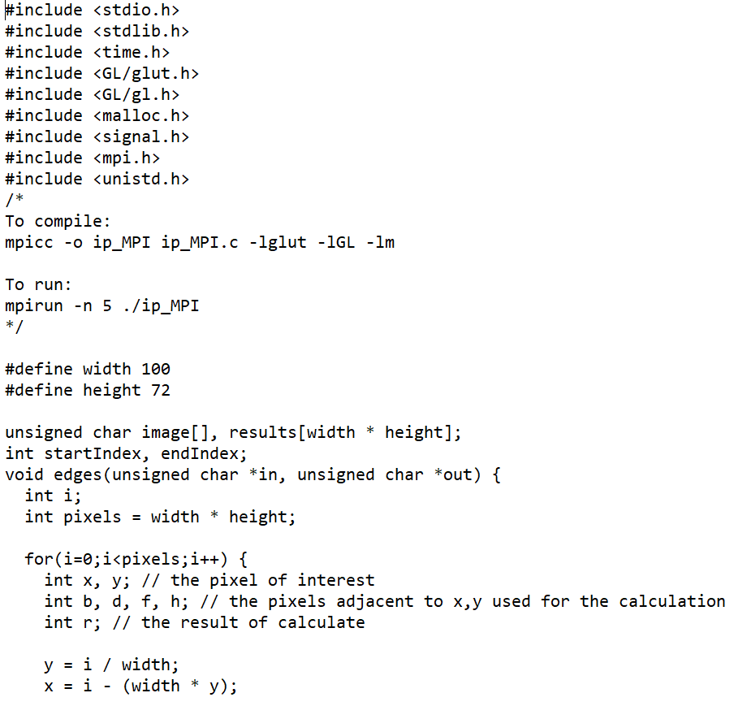

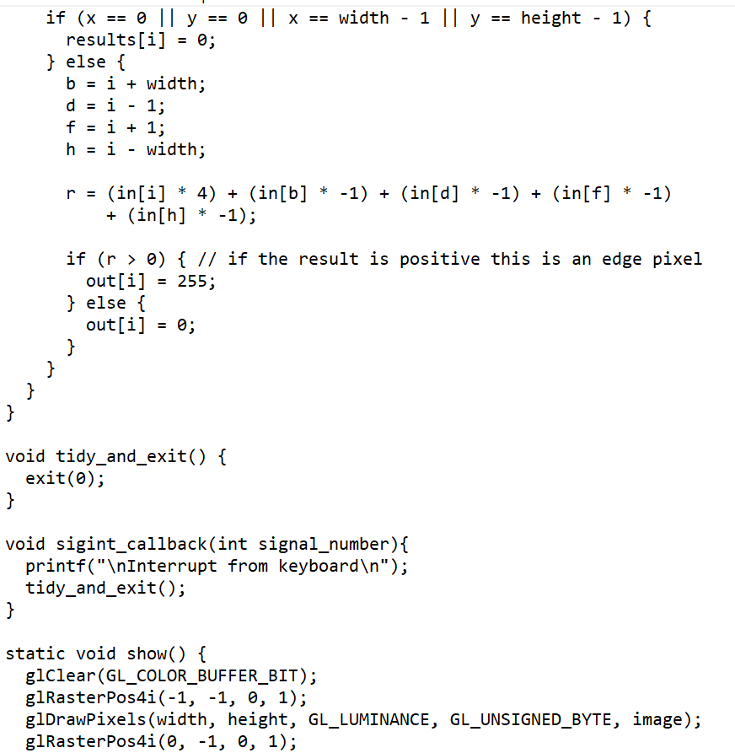

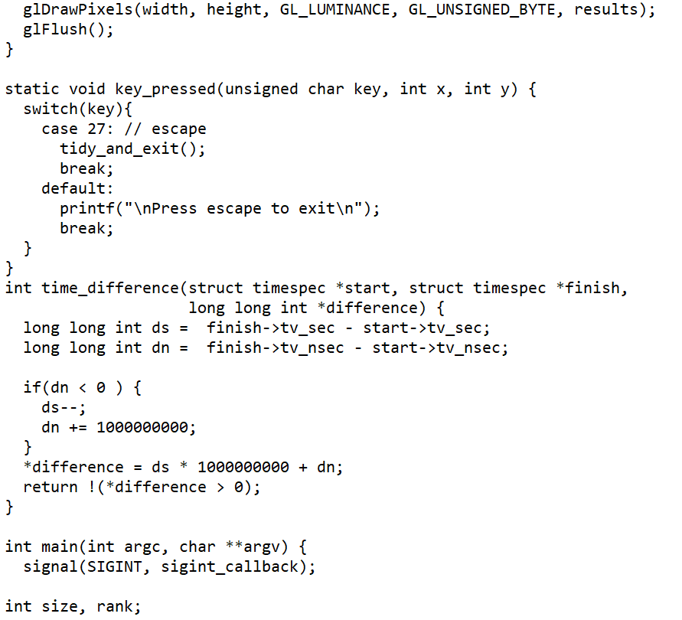

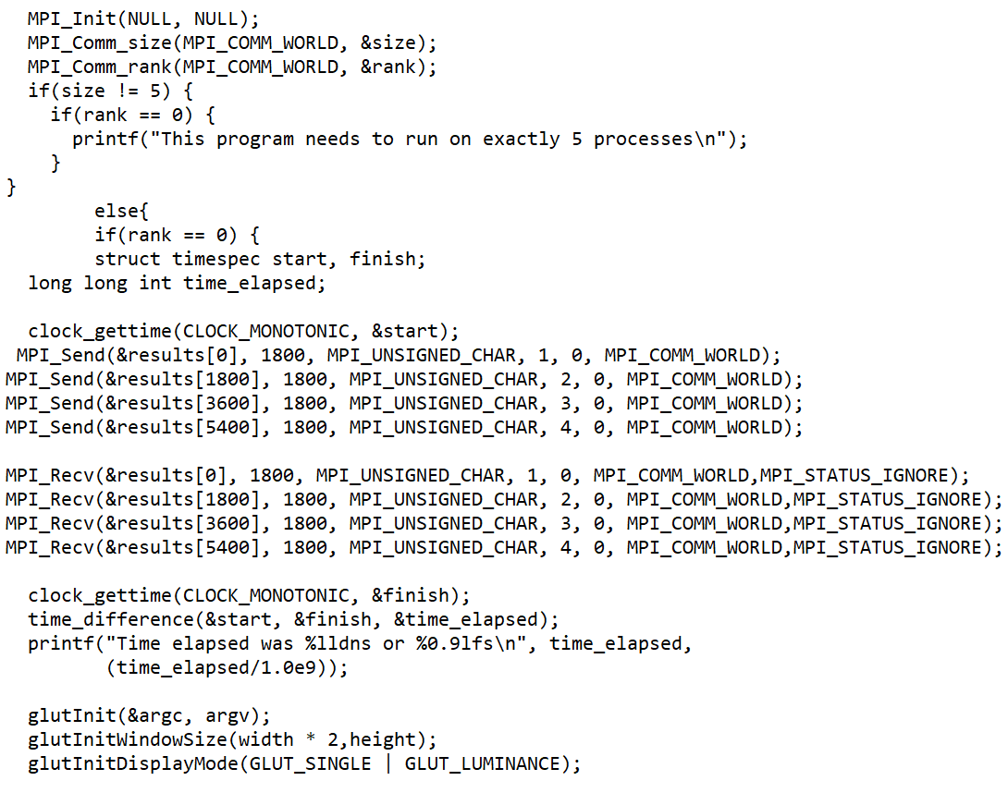

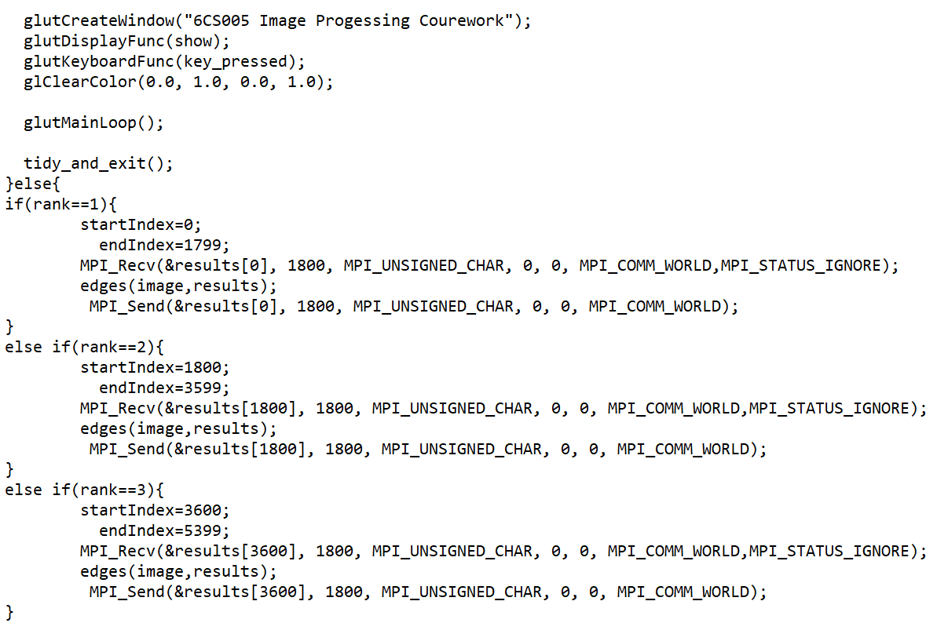

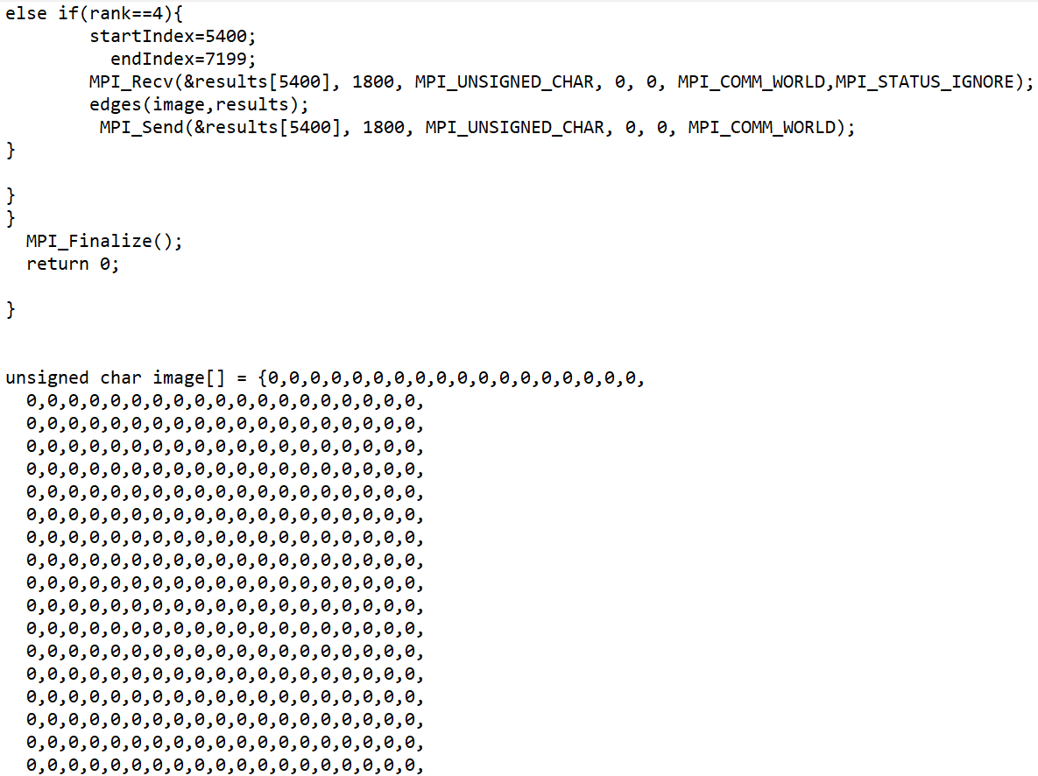

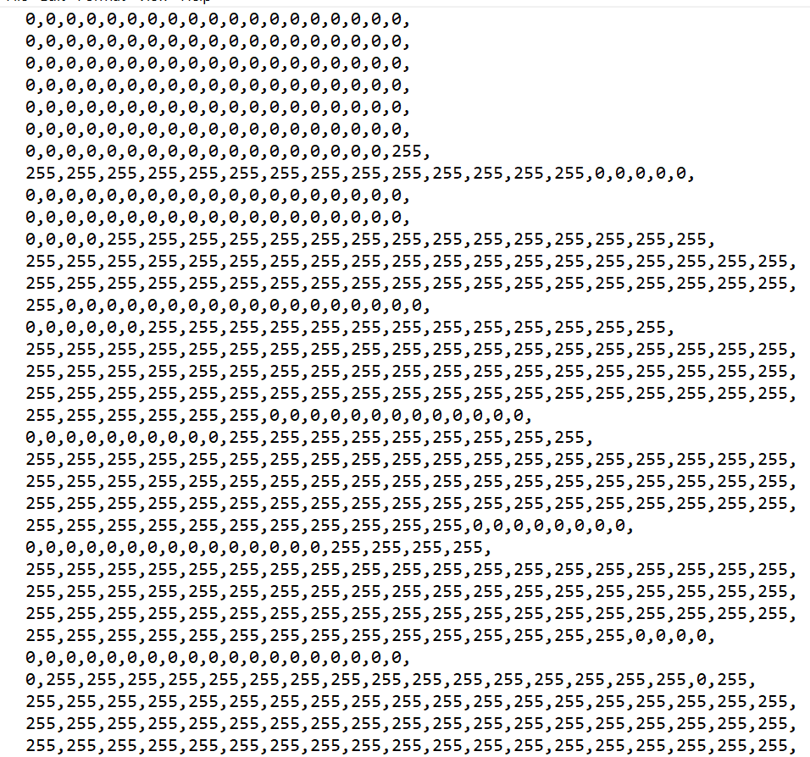

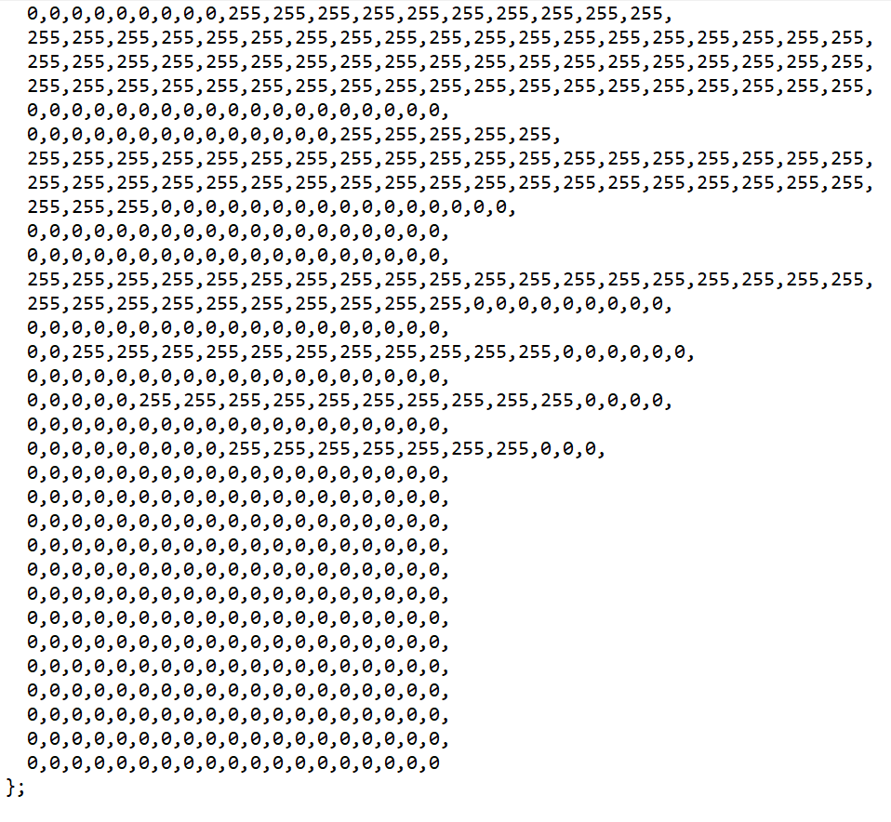

Calculating the average of the time required to execute the program:

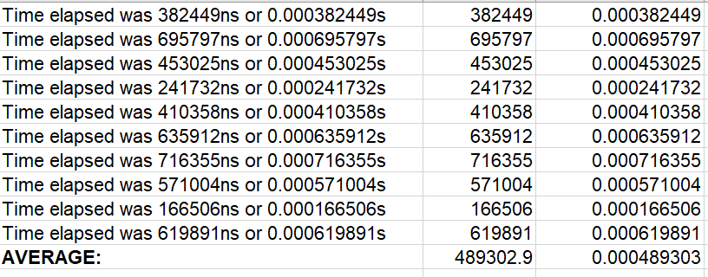

Insert a table that shows running times for the original and MPI versions. 

## **Linear Regression**

Compiling and running the program ten times:

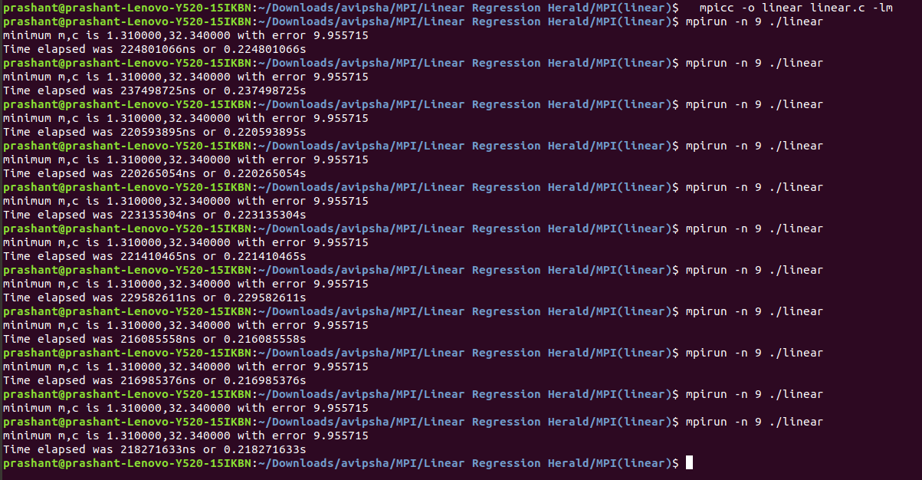

**Source Code:**

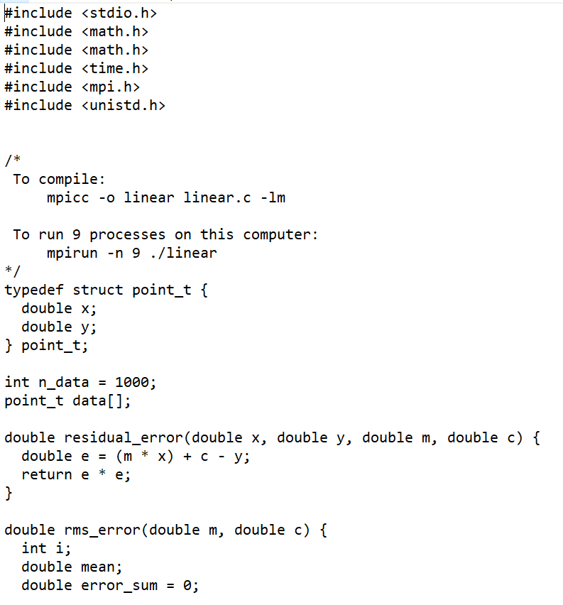

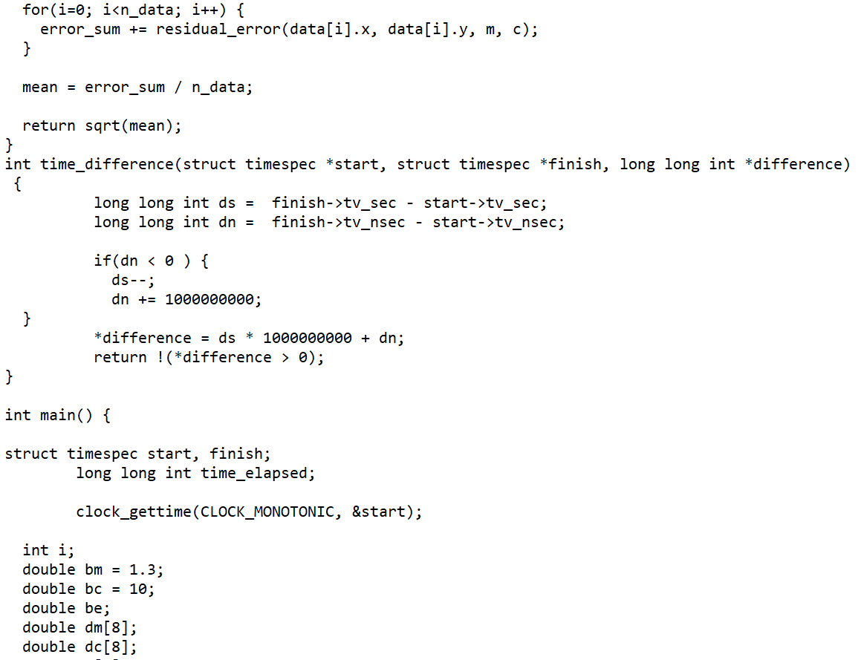

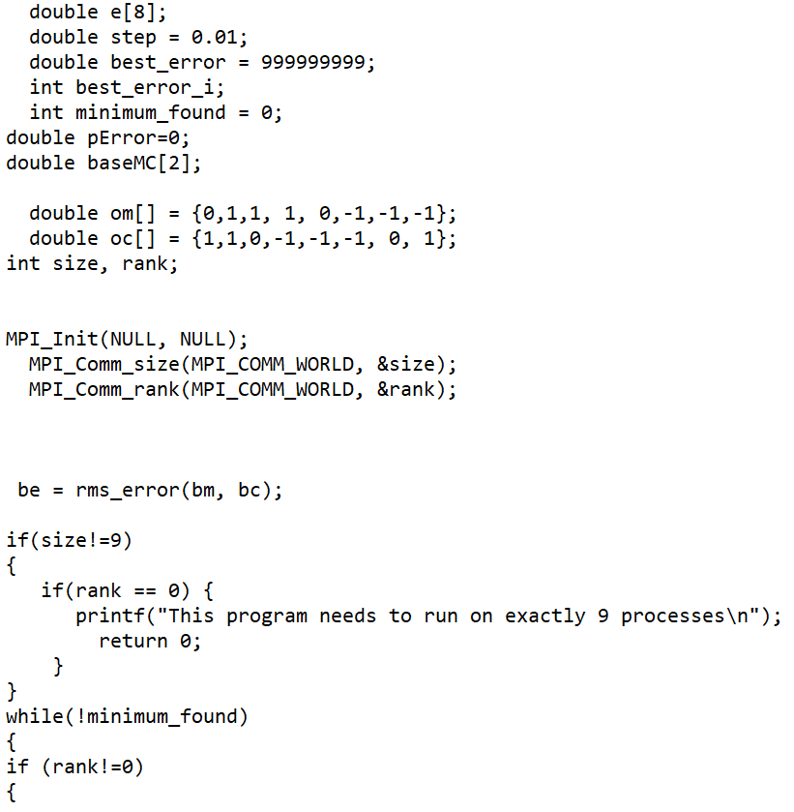

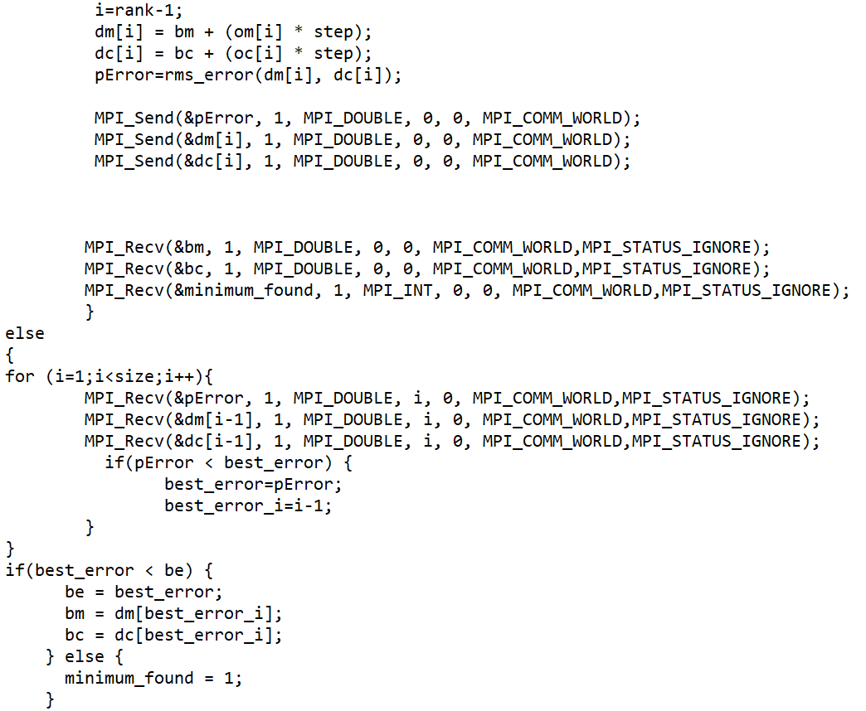

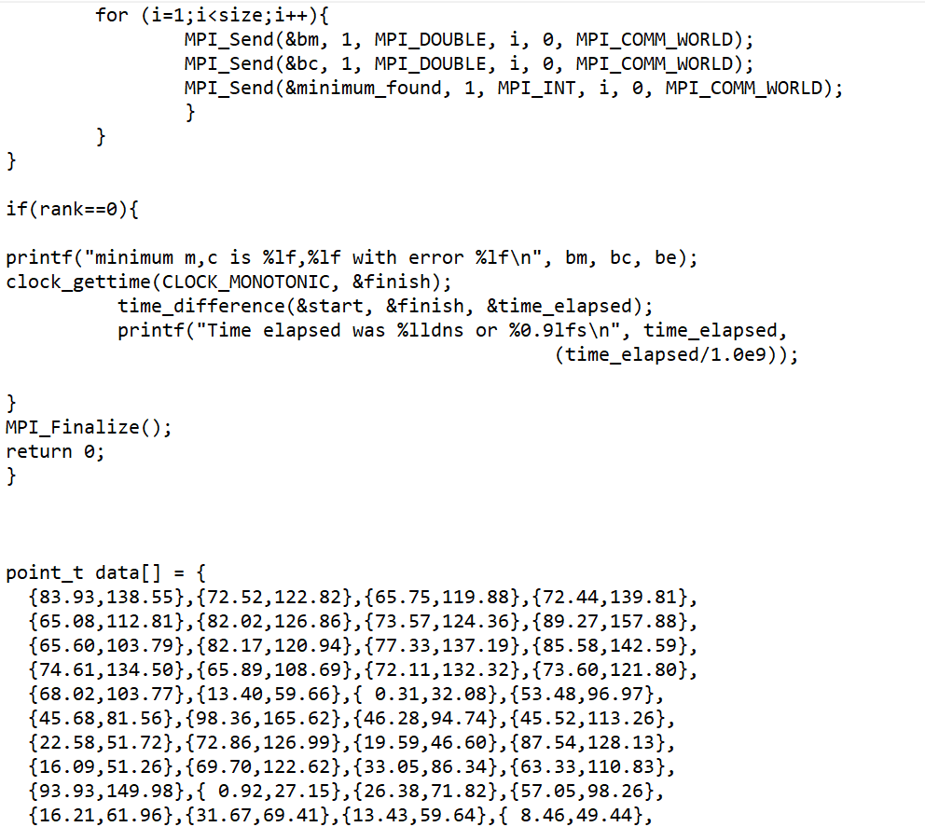

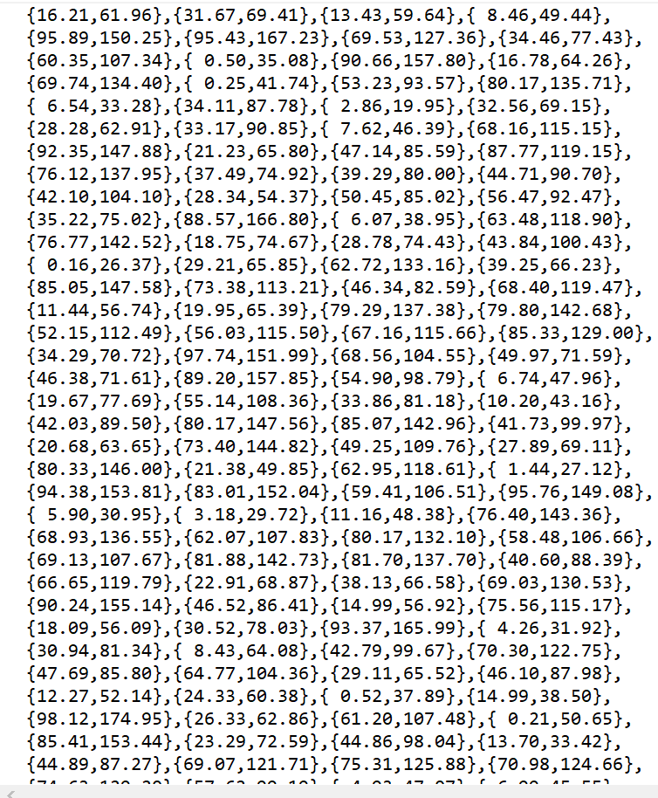

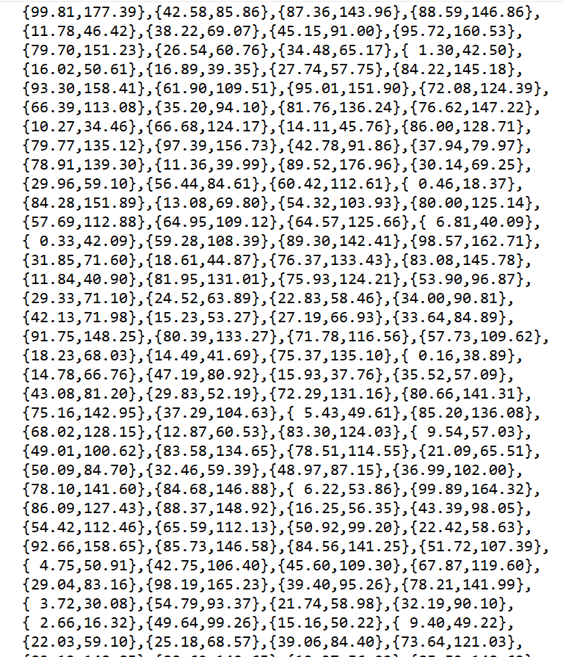

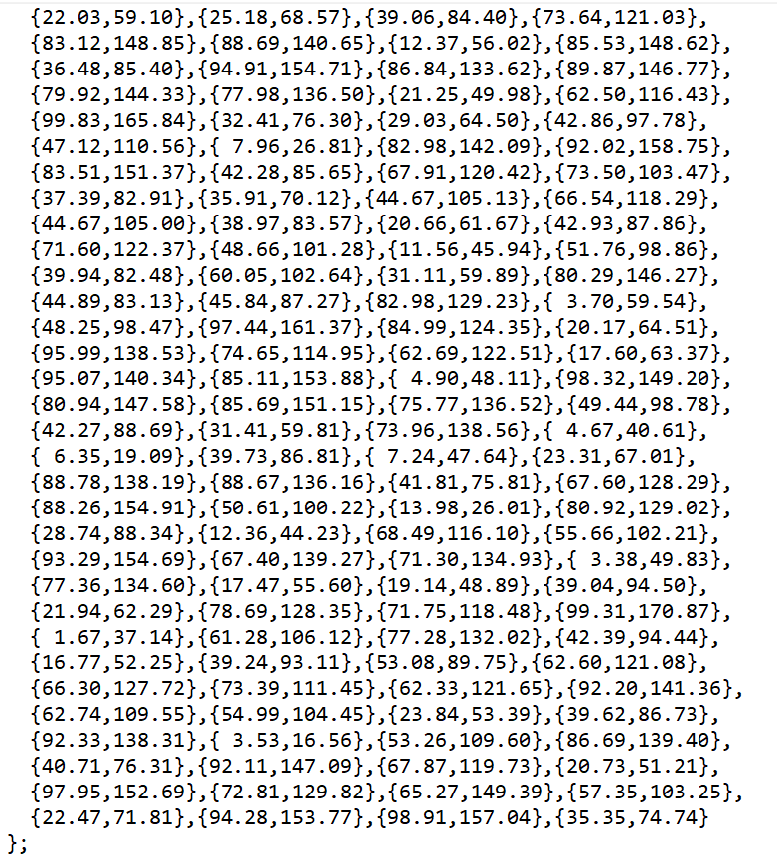

Calculating the average of the time required to execute the program:

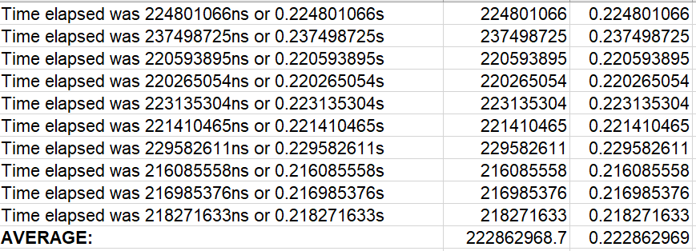

Insert a table that shows running times for the original and MPI versions. 

